eXplainable Artificial Intelligence (XAI)



by: The Fantastic Four

Team Lead - Andrew Anderson ([anderan2@oregonstate.edu](mailto:anderan2@oregonstate.edu))

User Expert - Souti Chattopadhyay ([chattops@oregonstate.edu](mailto:chattops@oregonstate.edu))

Design Expert - Samuel Lichlyter([lichlyts@oregonstate.edu](mailto:lichlyts@oregonstate.edu))

Writing Expert - Jeeeun Song ( [songjee@oregonstate.edu](mailto:songjee@oregonstate.edu))

**Chapter 1 – Project Description & Predispositions** **5**

Project Description 5

Usability Scenarios 5

Persona 5

User Predispositions 5

UI Predispositions 6

**Chapter 2 – Heuristic Evaluation (GenderMag personas)** **7**

The scenario 7

WORKFLOW evaluation 7

Motivations 7

Information-Processing Style 8

Computer Self-Efficacy 8

Attitude Toward Risk 9

Learning: by Process vs. Tinkering 9

DETAILED evaluation 11

Step 1 11

Motivations 11

Information-Processing Style 12

Computer Self-Efficacy 13

Attitude Toward Risk 14

Learning: by Process vs. Tinkering 14

Step 2 15

Motivations 15

Information-Processing Style 16

Computer Self-Efficacy 17

Attitude Toward Risk 17

Learning: by Process vs. Tinkering 18

Step 3 19

Motivations: 19

Information-Processing Style 20

Computer Self-Efficacy 20

Attitude Toward Risk 21

Learning: by Process vs. Tinkering 21

**Chapter 3 – Observation of Users in “the wild”** **22**

Research Questions 22

Process 27

The people in the space 27

1. Who are they, what are they like? 27

2. What are they doing? 27

3. How are they doing it? 27

4. What do their emotions, purposes, reactions seem to be? 27

5. What problems do they encountered with their activities? 27

The objects (technological and otherwise) in the space and with the people 28

1. What are the functional elements of the objects? 28

2. What are the decoration elements? 28

3. Which objects do people look for (perhaps to somehow interact with)? 28

4. Which objects do people bring with them that matter to the activities they are trying to do? 28

The environment: spaces, architecture, lighting, etc. 28

1. What is the layout? 28

2. What is the environment like? 29

3. How does it influence the activities people engage in? 29

4. How does the environment support the objects above?

What are the answers to your research questions? 30

What other insights did you get from this that are relevant to your "patient"? 39

**Chapter 4 - Gestalt, Design, & Tenets/Trap Principles** **45**

Gestalt Principles 45

Proximity 45

Similarity 45

Figure/Ground 45

Closure 46

Continuity 46

Symmetry 46

Common Fate 46

Tenets and Traps 47

Design Principles 49

Affordances 49

Feedback 49

Constraints 49

Consistency 50

Visibility 50

Prioritized Bugs 50

All bugs listed throughout Chapters 1-4 51

**Chapter 5 - Jake wishes to retrieve information about the decision points.** **53**

We found Home 53

More Information and Meet the Team 57

The Main Screen - Fixing the Blue Diamond 58

The Preview: Fixed Feedback Failure 63

The Viewer: Snapping Information 65

Snapped Saliency Feedback (Drill down functionality) 71

**Chapter 6 - Jake wants to see a continuous saliency map to see how the agent makes decisions over time:** **73**

We found Home 73

XUI, Meet the Team, Info Screen, Main Replay Screen 75

Voice Assistant Popup, Search by Keyword Popup & FAQ Popup 77

FAQ Page 79

**Chapter 7 - Jake wants to gain information about elements on the map by interacting with it.** **80**

Legend of elements on the map 81

More information about the elements on the map 86

**Appendix A - Future Use Cases** **87**

**Appendix B - Pre-Session Questionnaire** **88**

# Chapter 1 – Project Description & Predispositions

## Project Description:

As artificial intelligence becomes more pervasive in society, it is necessary that the bond between man and intelligent agent evolves to build trust that the agent, acting on the human’s behalf, is making the correct decisions for the right reasons. The eXplainable User Interface (XUI) takes a domain that “Jake” is familiar with, the Real-Time Strategy (RTS) domain, and tries to provide visual information for “Jake” to consume. These outputs help “Jake” to determine the reasoning that the agent is using to make its decisions. This interface is interesting from a usability standpoint because the temporal constraints that are placed upon “Jake” implies that any interface designed to provide this information must make sense, present the information in a logical fashion, and are arranged in such a way that “Jake” does not get lost in the process.

## Usability Scenarios:

1. Jake wishes to retrieve information about the decision points.
2. Jake wants to see a continuous saliency map to see how the agent makes decisions over time
3. Jake wants to gain information about elements on the map by interacting with it.

## Persona:

Please find attached a copy of AbbyPersona-modifiedJake.pdf.

Real Person Similar to Jake:

Our team is fairly confident that we can acquire a business major’s cooperation with a fair amount of RTS knowledge. However, the concern of one of our members is that including someone in our UI evaluations would detract from future user studies in the XAI project.

Failing this initial plan, one of our teammates knows someone that's not a CS major but very enthusiastic about RTS games.

## User Predispositions:

Things we don’t know:

* If Jake has a visual impairment
* If Jake has an auditory impairment
* If Jake has mobility issues
* If Jake’s first language is English
* Jake's computer skills
* Jake’s socio-economic status
* Jake’s gender
* Jake's sex
* Jake's learning style

Things we do know:

* Jake has an extreme interest in learning from this UI
* Jake opting in to using this UI means that he has either an interest in the RTS domain. He wants to learn what he can, whether to increase his gaming capabilities or to ensure that he can learn that the AI playing on his behalf is making the correct decisions for the right reasons.
* Jake's age
  + http://www.teamliquid.net/forum/closed-threads/280717-how-old-is-the-average-sc2-player
  + 39% ages 20-24 (N = 223)
* Jake rarely has free time
  + Abby persona assumption
* Jake has low self-efficacy
  + Abby persona assumption
* Jake is a comprehensive learner
  + Abby persona assumption
* Jake has no AI/ML knowledge

## UI Predispositions:

Things we don't know

* Can the information (such as the saliency maps) on the UI be rearranged?
* Can the information on the UI be changed?
* Different saliency maps, different reward decomp computations
* Is the UI currently catered to accommodate for those with color blindness??
* Does the UI currently have capability to support those with physical disabilities?

Things we do know

* Jake will not have access to lines of code pertaining to how the AI works
* AI cannot provide textual information about its internal reasoning
* It is limited to saliency maps and reward decomposition graphs
* The UI supports time controls, though the extent to which it does is somewhat limited
* The UI's presenting saliency maps (what the agent is looking at) and reward decomposition (the reasoning that an agent has based on the carrot or the stick that it receives for an action)
* The saliency maps visualize the intensity to which an agent is looking at objects on the map, so the brighter a pixel is, the more focus the agent had on that pixel
* This intensity is something that is not immediately obvious to Jake

# Chapter 2 – Heuristic Evaluation (GenderMag personas)

## The scenario you’re evaluating

“Jake wants to view continuous saliency map information to see how the saliency map changes

over time.”

1. Click on the blue diamond on the timeline
2. Click the play button
3. Stop

## WORKFLOW evaluation:

### Motivations:

**Make clear what a new feature does, and why someone would use it, while also keeping familiar features available.**

* **Jake**: He prefers to use familiar technology, so he is unhappy for motivations throughout the task. Although he wants to achieve his task, there are no familiar or comfortable features to keep him focused. Although there is the familiarity with time controls, they do not help him access saliency maps to understand the inner workings of the intelligent agent. He starts out feeling lost since he wants to see how they change during the game but is discouraged when nothing happens. Not only was he not able to do that, he wasn’t sure why he was getting saliency maps for different actions. He was especially frustrated when the diamond on the ‘explanations’ bar seemed draggable but was not. Jake is likely to not pursue the workflow to its conclusion, since the functionality is unclear.
* **Tim**: Tim loves using new technology. Tim seems to be quite happy in this instance, since there are a lot of new features that he might be able to tinker with. Tim might try the saliency map buttons then move on to try clicking random buttons until something happens that looks like it might be what he’s looking for. He was able to see many different types of saliency maps, and for many different types of attacks and outcomes. Those provide a good playground for him to discover more about the technology. However, he is frustrated that he couldn’t click on the elements of the ‘explanations’ bar or the elements of the video. By the 10th time step, Tim had already forgotten about the goal of viewing continuous saliency maps. In addition, he’ll be unhappy when he cannot access information easily. He isn’t getting the appropriate feedback from functions to understand more about the technology. Tim is the most likely to persevere to the end.
* **Pat**: Pat is willing to tinker around and find what they are looking for a little bit but would rather find what they are looking for quickly and get on with their day. When Pat clicked on the button in the explanations bar, they were happy to see the different saliency maps. However, if they don’t figure out that the diamonds are information points on a timeline, they are likely to just give up on the system. If also trying to click the saliency map buttons, it’s really a toss up if Pat gives up or not; if not and somehow manages to find the diamonds, then they will probably be good but frustrated.

### Information-Processing Style

**Let people gather as much information as they want, and no more than they want.**

This UI has some issues regarding providing information when the user wants it. From the first step of the workflow, neither of the personas will know what information they should be gathering. Something like a saliency map with randomly selected pixel clusters to give the user some familiarity with what information they will be processing (priming the user) will go a long way.

* **Jake & Pat**: Jake and Pat are unhappy when it comes to their information processing style. They want to learn as much as they can about the saliency maps, consuming as much information as they can before acting upon it. There is nothing to gather and nothing to read initially, and they are not provided with the necessary information to learn more or read more about saliency maps. There are currently no textual information/explanation, help buttons, or instructions as to how to interpret the information on the screen.They don’t know that brighter pixels are more salient to the system, for example. This lack of ability to gather information will lead them to abandon their task early on in the workflow. In the other hand, when saliency maps are given in Step 2, Jake and Pat are happy with the interface because when they get to the information they’re looking for they have access to a bunch of different information types and can take it all in and then move on to the next diamond.

* **Tim**: Tim is generally happy from an information-processing standpoint. Tim loves to click the various options to see different information regions. He still perseveres through the lack of feedback, digging around and able to undo his actions. After Step 2, he is able to backtrack by clicking on the same diamond that is highlighted yellow. Tim is likely to persevere until the inevitable conclusion that the functionality does not exist in the current version of the UI.

### Computer Self-Efficacy

**Make available ALL of (1) familiar features, (2) undo/redo, AND (3) ways to try out different approaches, to support ALL self-efficacy levels.**

* **Jake:** There aren’t many familiar features or UI elements, so he is feeling lost and when he messes up, he is very likely to feel like he did something wrong and give up. He wanted to understand the agent’s performance, but with every step he got more confused. There was no way for him to know if he was taking the right step. Especially with so many options when he wasn’t able to see a continuous saliency map he was blaming himself. Perhaps what frustrated him the most was the diamond on the explanations bar seeming to be not clickable. He tried several times to drag it. For example, suppose Jake, with low self-efficacy, accidentally unchecks all of the boxes for the saliency maps. There should be some undo button that will allow him to get the saliency map back. However, there exists no functionality for this at the moment. He is likely to abandon the task early on in the workflow, since he does not see familiar features and is unaware of how to undo/redo his actions.
* **Tim:** Tim is willing to mess around with the system a bit, so he’s likely to keep trying out different approaches to try to regain any lost information. However, he’s going to end up frustrated with the system not complying to his standards. He might feel like the system is broken or poorly designed if he can’t figure out how to get to the saliency maps since he usually blames the technology. He might still think this when he finally figures out how to get to them. Then, he explored the various saliency maps he could get from the various options, instead of trying to find the continuous map.
* **Pat:**  Pat is willing to try to interpret information, but they might give up after a while if they can’t figure out what they need to do to get to the saliency maps. Since their objective is to find out about continuous saliency maps, and they are more likely to persist when things get hard, Pat is likely to dig through the information environment longer than Jake would but shorter than Tim.

### Attitude Toward Risk

**Make available why someone should use the feature (benefits) and how much effort it will take (cost); doing so supports decision making, no matter their attitude toward risk.**

* **Jake & Pat:** Because Jake and Pat don’t have a lot of spare time learning new features, they often don’t want to poke around a system for too long. The timeline is a familiar concept, so they were lured into an ‘inviting dead end’ element—the diamond on the explanations bar—and they miscalculated the cost. The benefits are also not clear. Pat spent a lot of time trying to understand the maps. But it still didn’t show how the agent’s focus changes. There also seem to be two timelines and figuring out what each one is for is costly and they both might give up before they figure it out. Overall, this UI will not make them happy campers. There is little feedback as to the benefits of clicking on buttons or scrolling around to different parts of the interface, and the cost is not readily available to the users.
* **Tim:** Tim gets distracted by exploring new features but is happy to poke around a system and learn everything it can do for him. This system offers a lot for him in this regard.  He was satisfied that he can very easily access the different saliency maps for very low cost. Due to such low cost design for the different elements on the UI, he overlooked the benefit. If he messes up and finds other features he wasn’t necessarily looking for, he might get distracted and get lost in the exploration not related to his primary task. However, since he might tolerate the lack of obvious benefit, he can tolerate the wait for the information.

### Learning: by Process vs. Tinkering

**Provide a path through the task for process-oriented learners, and for tinkerers, encourage mindful tinkering (e.g., slow them down with an extra click), so that it is not so addictive**

* **Jake:** Jake would prefer a tutorial on how to find the saliency maps and how to interact with the different ones he can find, but no instructions/explanations are given to go through the workflow. There was no tutorial or guidance, and Jake was forced to tinker. He is not receiving any path through the task, and there is nothing detailing what to do next. There are a lot of issues for process-oriented learners such as Jake.
* **Tim:** Tim is perfectly happy exploring all the different saliency maps to find the ones he’s looking for and might even get a little off task exploring ones he isn’t necessarily looking for. There’s no constraints to stop tinkerers from addictively tinkering. The workflow allowed him to tinker as much possible. Perhaps a bit too much, so that he got carried away and started to explore the various ways he can invoke the saliency maps.
* **Pat:**  Pat’s mindful tinkering allowed her to gain knowledge by comparing maps. Pat might be happy, since they reflect on each step that they tinker with. Pat also learns by jumping right in but does so carefully and methodically, knowing exactly what they are looking for and thinking of how to get there every step of the way. They might feel satisfied after finding interesting information by comparing two maps. When they reflected on it, they realized that they still don’t understand how the agent actsas the game progresses.

## 

## **DETAILED** evaluation:

### **Step 1:**

Click on the blue diamond on the timeline.

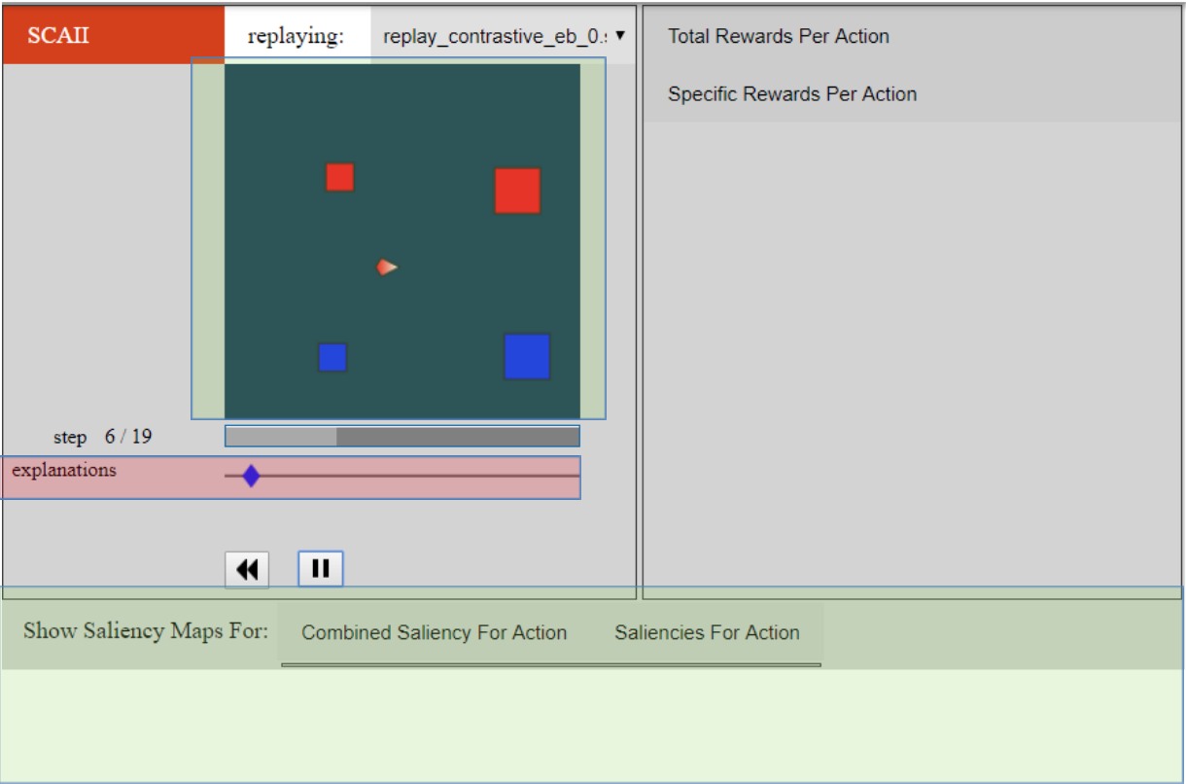

**Fig.1 To get to Saliency maps one has to ‘click’ on the blue diamond (red box).**

#### Motivations:

The Green Regions highlight the areas that are of high interest to the user. However, the tabs and text provide no indication as to what this feature does or why someone would use it (BUG #1, T&T #4).  At this stage, the user would want an example of a saliency map, which they aren’t getting.

The Red region is the place the user has to go to. However, the bar is an invisible element (BUG #2, T&T #1) and the blue diamond is an uncomprehended element (BUG #3, T&T #4). It appears like the playhead for the video, but is actually a button. It is also a case of Forced Syntax (BUG #4, T&T #7) where the user is forced to do something not natural to them.

**Jake**

* Jake knows he wants to see a map over time. He doesn’t see any map on this screen. He looks for the word ‘Saliency’ and tries to interact with the tabs with the word saliency on it, but nothing happens.
* He tries to click on the video, but nothing happens there either.
* Jake sees a play button, a rewind button and a blue diamond on a bar. He is confused if this bar is called ‘explanations’, and what that means. He tries to drag the blue-diamond on the bar but it is not draggable. He finally clicks on the diamond, and the maps emerge. He was not happy since he wasn’t familiar with it.

**Tim**

* Tim might tinker around and try to see what the system can give him before settling in on really trying to find the saliency maps he’s looking for.
* Tim loves to click, but there were no instructions on what to click to get the maps.
* He played the video using the play button and quickly clicked on the tabs beside “Show Saliency Maps For”. But that didn’t help.
* He finally clicked on the blue diamond and the maps emerged.

**Pat**

* Pat was also a little confused about what to do.
* They slowly tried out the different tabs and button.
* They did not expect the blue diamond to have been clickable.

#### Information-Processing Style

There is no information displayed other than the time steps. This seems insufficient for the user (BUG #5, HEURISTIC: Info-Processing Style), since they want to see how saliency adapts over time. Though it refrains from overwhelming the user, it feels inadequate for Jake and Pat who want to gather more and read everything before acting upon it. The information from the Green Regions was insufficient, and the red region showed no clear pathway.

**Jake**

* Looks at everything on the screen to engage in sensemaking for saliency maps.
* No information present about what the UI contains
* Looks for information in the tabs and what buttons mean
  + Finds nothing
* Looks for a menu, FAQ, or guide
  + Finds nothing
* Tries to drag blue diamond
  + Does nothing (dissatisfaction grows)
* Clicks play
  + Does not show saliency maps (dissatisfaction grows more)

**Tim**

* Sees the play button
  + Clicks and plays game
  + Can undo actions if unwanted event occurs
* Sees many more potential buttons
  + Starts clicking around
  + Can lead to addictive tinkering
  + Forgets task at hand
* Clicks blue diamond
  + Something happens
  + Success!

**Pat**

* Clicks on buttons and tabs
  + Waits to see what happens
* Tries to make sense of tab titles
  + Insufficient information
* Tries to drag the blue diamond
  + Disappointment
* Continues to look for other information
  + Still disappointed

#### Computer Self-Efficacy

All personas are likely to continue on with their task, despite the lack of saliency information (BUG #6, T&T #9). Tim probably thinks that it’s a glitch in the system, whereas Jake and Pat are probably wondering if they have made a mistake during installation or if they haven’t clicked on the right thing yet. There aren’t any familiar features with this interface from playing RTS games, so it’s frustrating to Jake and Pat that there are no familiar features. At the first stage, there isn’t anything to undo or redo, and there’s nothing obvious about a single approach to gain continuous saliency information, let alone trying out *different* approaches (BUG #7, T&T #9).

**Jake**

* Blames self when he tries to access buttons having to do with saliency
  + They do nothing, so it hinders his progress
* Clicking on the blue diamond helps him feel like he is moving towards his task, which eases his anxiety about using this interface
  + Frustration grows since there was no indication that this was meant to be an intended step

**Tim**

* Clicking everything that is available, and it does not frustrate him
  + It will make him dislike the system if he can’t figure it out quickly

**Pat**

* Tries poking around at the system by dragging the blue bar first (no response)
* Clicks the diamond by mistake, and the maps pop up
  + Might give up after some time if they can’t figure out how to bring up the saliency maps
* Worry sets in that they might have done the wrong thing

#### Attitude Toward Risk

Neither the benefits of this system or the cost are available to the user, so there is nothing to support decision making. Tim is likely to be okay with it because he is risk tolerant, but risk aversion detracts from people’s desire to use the system because there is no explanation of why someone should use these features. There’s a lot to learn about this system, despite some familiar features (play, rewind), which detracts from Jake and Pat wanting to interact with the system.

**Jake**

* Does not understand what is meant by ‘’explanations’’
* Forages around the interface for other possible options
* Eventually forced to click on blue diamond since he’s out of options

**Tim**

* Unconcerned with the lack of benefit
* Did not perceive a high cost for clicking on the blue diamond

**Pat**

* Connected that blue diamond is related to explanation
  + Couldn’t figure out how to use it
* After a couple of attempts to drag, they worry that no information is forthcoming
* Eventually click to see what happens, with success!

#### Learning: by Process vs. Tinkering

There is no cue to indicate a path through the task for process-oriented learners (BUG #8, HEURISTICS). The interface as it stands right now encourages tinkering, though there is nothing to discourage addictive tinkering

**Jake**

* Frustrated because he wants to gather information of this new data type, but nothing on screen to invoke it
* Only tabs that contain the word “Saliency” give no feedback
* No way for him to learn that the blue diamond invokes the maps
* Feels lost at this point, making him want to give up on the task

**Tim**

* Needed no instruction, found the maps through tinkering
* Excited to continue his investigation

**Pat**

* Connects the concepts between ‘explanations’ and the bar
* Has a hard time interacting with the bar to see its usefulness
* Willing to click around to see what everything does in their attempt to find saliency information

### Step 2:

Click the play button.

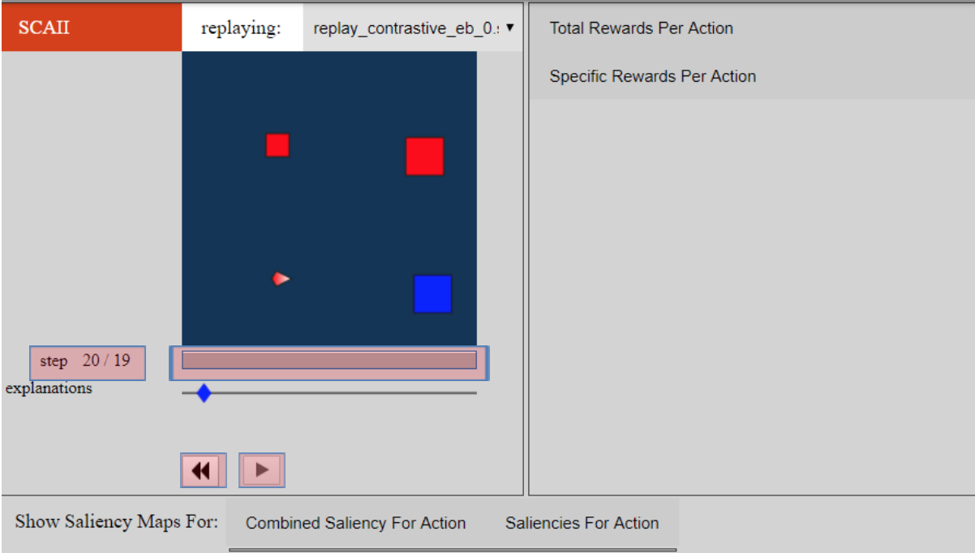

#### Motivations:

The time controls are familiar constructs for the users -- play, pause and rewind -- and are consistent with external environments. The feedback between play and pause is good. This keeps a familiar feature available, and it’s good that the UI makes the user aware of their action and why they should be using it. The labeling of the timeline is a bit misleading (BUG #9, T&T #4,6).

**Jake**

* By this time, the controls have become familiar features to Jake, so he’s more settled in his task. Jake watches the game.
* He keeps and eye on the maps along with the game. But nothing changes in the maps.
* He doesn’t find any other button and starts giving up.

**Tim**

* He played the game and watched the game only.
* Played it again to see if the maps change. He then started to click the ‘previous’ button to see if anything happened.
* At this point Tim tries to focus on the ‘attack bottom_left’ option and it’s maps.
* Tim has found even more information to try to process, and he’s intrigued by what new things he’s away to learn.

**Pat**

* Pat looks at the maps throughout the game.
* They didn’t see the yellow diamond on the explanations bar move.
* They tried to click on different positions on the explanations bar to see if the maps change.
* Pat might try out other features or finish up looking at the saliency maps since they don’t have much time.

#### Information-Processing Style:

More information has been gathered, since the user now knows what happens throughout the game. UI overloads the user with information. Though the UI enables the user to advance through time to see how the system changes, there is no information displayed other than the time steps (BUG #10, T&T #___). This seems insufficient for the user, since they want to see how saliency adapts over time. It feels inadequate for Jake and Pat who want to gather more and read everything before acting upon it.

**Jake**

* He sees that the agent kills the small blue box. But the maps called Friend and Enemy doesn’t highlight that region.
* Lacking anything to read, he starts to look for visual information in the graph. He wonders why it has 4 attack options when only one attack (bottom_left) happens in the video.
* He is running out of options to click and he has nothing to read.
* Inadequacy in terms of amount of readable information.

**Tim**

* Tim played through the video multiple times.
* He tried to interact with objects on the video, but to no avail.
* At this point, he has forgotten about the continuous maps, and now is solely trying to understand form whatever information he has, why the small blue box was attacked.
* Tim will probably play around with each item that appeared on screen and backtrack if need be.

**Pat**

* When no information changed in the maps, Pat started to realize that continuous maps were not possible and they have to gain information from all maps at the same point.
* They wonder what to do next, since none of the buttons seem to provide any information on how to get saliency maps.
* They look for a guide/help button, but none exist.
* Inadequate amount of information to read.

#### Computer Self-Efficacy:

There is no way to try out different approaches to try and make saliency information present in the UI at this stage (BUG #11, T&T #7). Pat will persist through the task, since they will keep on trying for quite a while.

**Jake**

* At this point, Jake has given up on finding continuous maps.
* He just wants to see if he can make any sense of the data, starting to think this is beyond him.
* He wants to replay the file to make sure that she can undo something that she might have missed the first time.
* But once he sees that even after playing the video the maps don’t change, he starts giving up.

**Tim**

* Tim feels the same as Jake and is curious if there are other ways to get to this information.
* Tim wants to try out a different approach to the problem.

**Pat**

* Pat didn’t lose confidence,they instead decided to understand how the agent plays by looking at the various maps.
* Pat will persist through the task, since they will keep on trying for quite a while.

#### Attitude Toward Risk

There is no information about the benefits or the cost for using the play button (BUG #12, T&T #9). Even watching the replay, there is nothing that indicates the information that they should be getting out of the system. The arrow head begins moving down towards the bottom-left, but there is no accompanied saliency explanation (BUG #13, T&T #9).

**Jake**

* Jake was running out of features to use.
* He had no option to interact with the maps. He wanted to reload the window, but feared it might break something.

**Tim**

* Tim dove into looking in the graphs and the various options very minutely.

**Pat**

* Pat also decided that since she couldn’t find any way to get the continuous maps, and there is no guarantee they will get that information, they will find information from existing maps.

#### Learning: by Process vs. Tinkering

During this step, there is not much to tinker with in the UI. Tim is probably a bit engrossed by the moving arrow head, and Pat is reflecting on their action leading up to this step, wondering what has changed.

**Jake**

* The path through the task has not been illuminated, so Jake is frustrated and wants to give up on this task. It feels like there’s no end in sight for him towards accomplishing her task.
* Normally, he would give up at this point.
* The only information for Jake to follow was that on the saliency maps. He wanted to methodically explore that.

**Tim**

* Tim has lost himself in exploring. He forgot he was trying to get the continuous maps and started to just explore.
* Tinkerers will probably end up clicking on the saliency map to see if they can change it or if they can zoom in on it. This promotes addictive tinkering.

**Pat**:

* Pat moved on to reflecting on the maps.

### Step 3:

Stop.

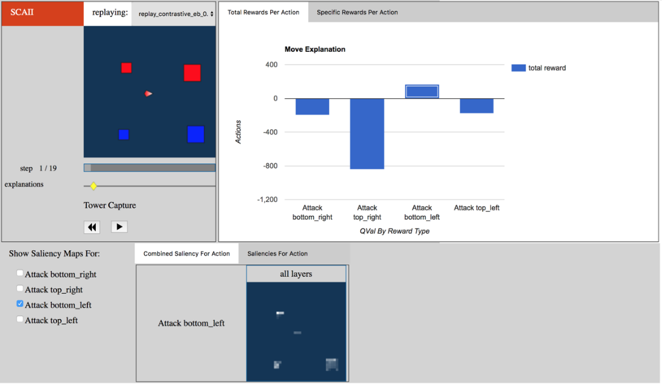

#### Motivations:

At this point, the motivation for the personas has dwindled. They have become aware that they are unable to retrieve continuous saliency information, so the only motivation they have is to close out the application because they cannot get what they want out of the system.

**Jake**

* Jake’s frustration has grown to such an extent that he is filled with disappointment; he reaches for the [ x ] and closes out the UI.

**Tim**

* Tim has forgotten what his initial task was, so he continues to forage around the UI aimlessly.

**Pat**

* Pat might try out other features or finish up looking at the saliency maps since they don’t have much time, but they might also close out of the UI, reaching for the [ x ].

#### Information-Processing Style:

The personas, by this time, have decided that they will close out the system, discovering that they cannot access the functionality in this UI that they seek. They all bring in the external context that the [ x ] in the top, right hand corner will close the program, so they are likely to apply this knowledge to ending their task.

**Jake**

* Jake will give the screen one last look, just to be sure that they haven’t missed anything.
* Filled with disappointment, he reaches for the [ x ] and closes out the UI.

**Tim**

* Tim will likely explore the features inside this first information point before moving on to the next one.
* Once he has discovered that continuous saliency is not a viable function, even with tinkering, he reaches for the [ x ] and closes out the UI

**Pat**

* Pat, similarly to Jake, will first make sure they haven’t missed something before reaching for the [ x ] and closing out the interface

#### Computer Self-Efficacy:

Jake thinks he has done something wrong. Tim thinks the system is broken. Pat thinks they have tried reasonably everything at this point in time, so the only thing left to do is quit.

**Jake**

* Jake feels like he has messed up during his task, unwilling to blame the system.
* Jake reaches for the [ x ] to close out of the system

**Tim**

* Tim, frustrated that it took so long, figured out how to get to the saliency maps is now free to explore other ways at getting to them, though he begins to blame the system for a lack of continuous saliency information.

**Pat**

* Pat is also happy they figured out how to get to the saliency maps and is confident they can get to other functionality.

#### 

#### Attitude Toward Risk

Benefits are perceived to be low, and the cost of obtaining the information is too high. The time the personas spent foraging for the information was too long for the value they gained, although their expected value was probably much higher when the saliency maps displayed.

**Jake**

* Jake is risk averse, and once he has decided that he is not likely to get the information that he desires, he will feel like the cost is too high and benefits too low to continue with his intended task.
* Jake reaches to close out the interface.

**Tim**

* Tim is free to explore new features of the saliency maps he has discovered.
* However, even with tinkering and being risk tolerant, Tim feels frustration that he is unable to access the information that he desires.

**Pat**

* Pat’s attitude towards risk allow them to persevere longer than Jake would, but they still can only tolerate so much before they reach for the [ x ] to close it out.

#### Learning: by Process vs. Tinkering

There’s nothing more to tinker with for the personas, and they haven’t obtained anything towards understanding continuous saliency.

**Jake**

* Jake has reached the end of the process, and the path forward does not exist.
* The only thing left to do is close out the system.
* This is not the system he is looking for.

**Tim**

* Tim is all tinkered out.
* Tim has figured out how to get to the saliency maps, so he is happy about that.
* Having obtained no relevant information for continuous saliency maps, Tim reaches for the [ x ].

**Pat**

* Pat likely won’t try out new features since they discovered the one in which they needed to accomplish their desired task.

# Chapter 3 – Observation of Users in “the wild”

## **What are the research questions/goals:**

Our Research questions are modelled around the workflow that a user needs to follow to achieve the goal of the application – to be able to explain the behavior of the agent in the game by using additional information that the UI provides. Towards that, we have the following RQs:

1. How do users interpret time based elements?
2. What information does the user find helpful when trying to explain the agent’s behavior?
3. What elements of the UI does the user struggle with during the workflow?

## **Process**

## **How did you proceed to answer these questions? Be detailed. For example, if you conducted an interview, list all the questions. Where and when did you collect the data? How did you set up to allow triangulation, etc.**

See attached questionnaires for questions asked and recruitment poster for how we lured in participants (unsuccessfully).

We started off selecting a scenario which would require the user to go through the longest workflow possible in the app. We selected the scenario where the user needs to explain the agent behavior (Chapter 1).

We formed a small 6 question Pre-Session questionnaire. **[See Pre-Session Form.doc]**. The questions were:

1. Name

2. Age

3. Gender

FEMALE MALE OTHER

4. What is your major?

5. What is your all-time favorite RTS game?

6. Approximately, how many hours per week do you play RTS games?

7. What is your preferred platform when playing RTS games?

After the questions, the same page has a section labelled “Task” which contained the task prompt as follows:

“This is a tower capture game. The blue are your enemies; the red are your friends. The tiny triangle in the center is the player who plays the game.

This is a replay of the game played.

Find out why the player makes the decision in the game by retrieving more information from the application.”

Here is an image of the questionnaire:

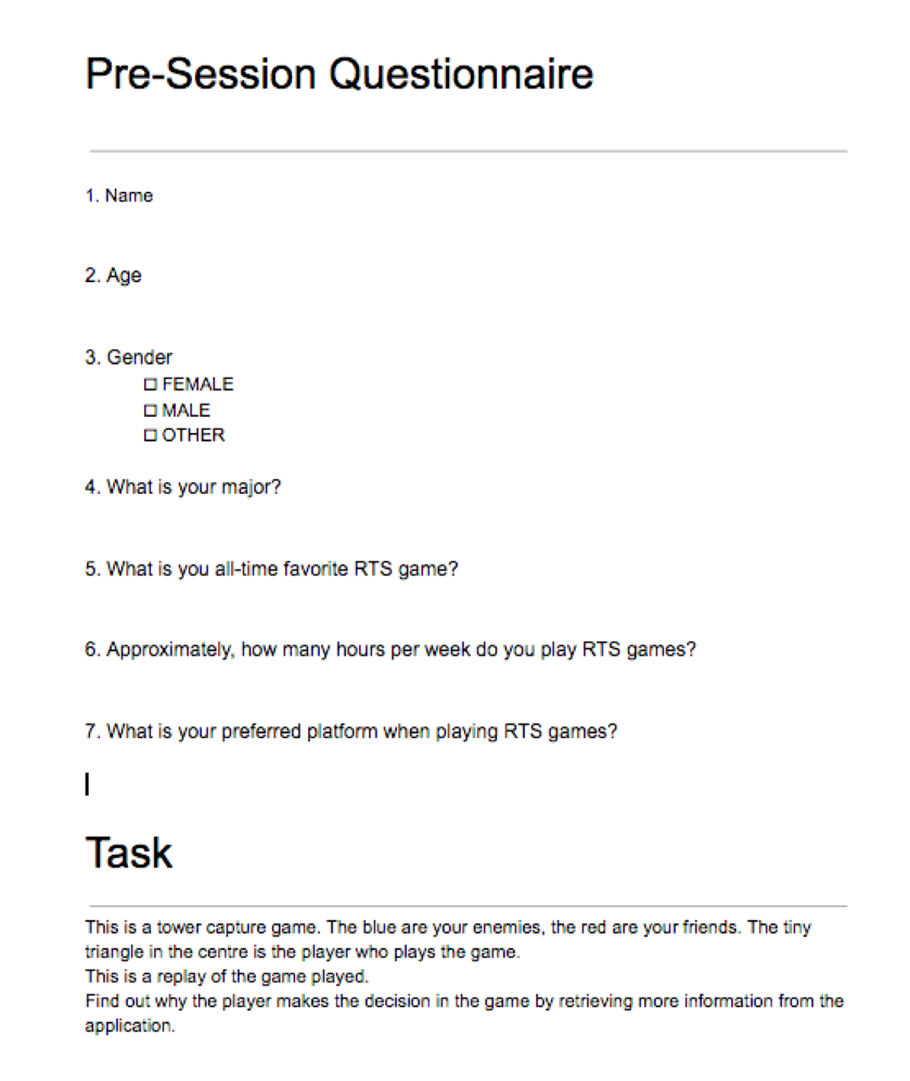

We conducted 2 pilots on fellow CS PhD students from the KEC 2130 lab (who are not taking the CS565 class). In both the first and second pilot, the users successfully explained the agent behavior using the graphs. However, in both cases, the observers had to point out where to click (“blue diamond”) to find more information.

This was concerning, and we immediately knew that no participant will be able to find the blue diamond’s function by themselves. So, we initially decided to change the task prompt where we would start the task from a point where the blue diamond will already be clicked.

But something interesting happened during Pilot 2. The participant clicked the blue diamond accidentally while trying to drag it. But when the graphs and saliency maps popped out, the participant freaked out and became nervous thinking he broke something. He immediately went back and clicked the blue diamond again to make the graphs go away.

After seeing this, we decided to keep the task prompt as is, to be able to observe if any such “accidental” cases occur.

For the real study, we wanted to specifically control for the student’s major i.e. we did not want anyone whose major would be CS. So we took a passive approach. We made a poster **[See attachment: Poster.pptx**], to lure in participants with the offer of free coffee. Here is an image:

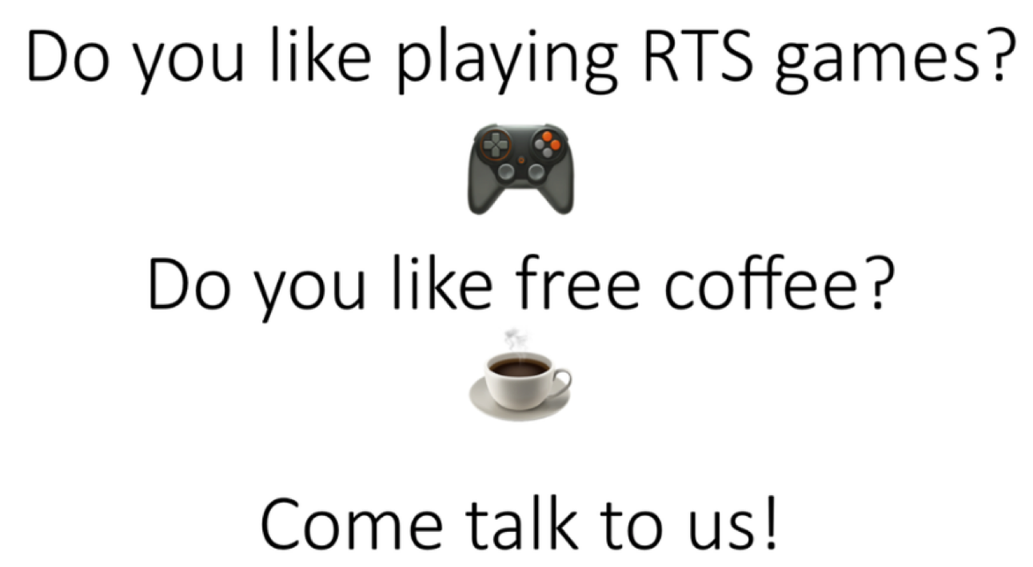

On Thursday, we went to Austin Hall’s (Business Studies) second floor commons, put up the poster and waited for participants for 3 hours. Unfortunately, no one came up. So we went to the same place the next day and approached any student who was not immersed deeply into a book or computer.

**Participant 2 [Back-up, Triangulation]**

We approached them with the question “Do you play RTS games?”. We inferred, that any avid RTS games (pre-req for our study) will be able to identify what RTS meant. We found a participant who claimed to know and play RTS games. We gave out the Pre-Session Questionnaire to him. [**See attachment: Pre-Session_2**]. Here is an image of his responses:

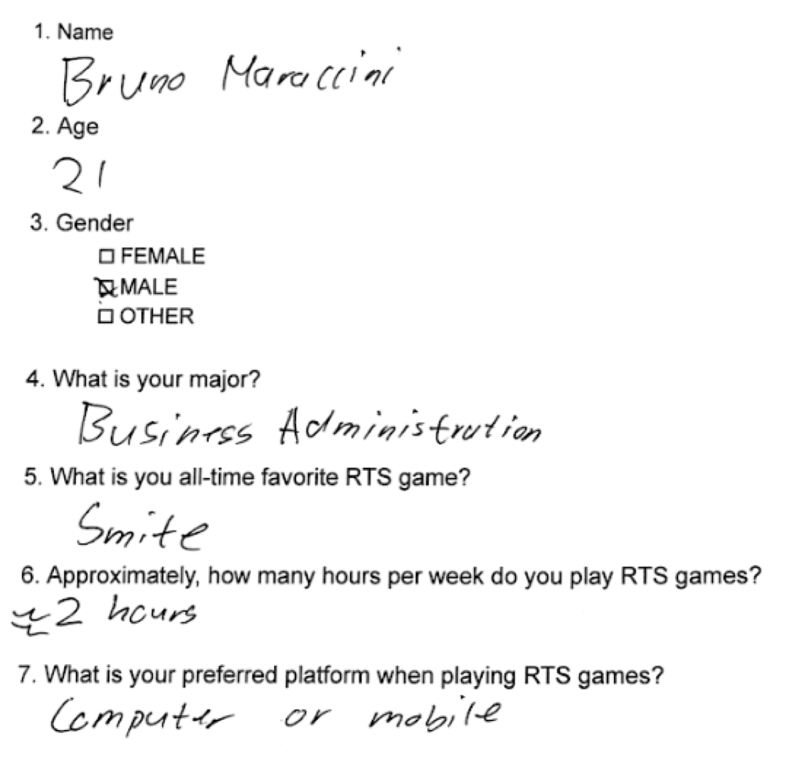

One thing we noticed immediately was, his favorite game “Smite” is not an RTS game, but a variation of it [MOBA: Multiplayer Online Battlefield Arena]. He told us that he could not remember the full form of RTS.

We decided to keep him as a back-up participant : **Participant 2**. We use the data from his observation session to triangulate our findings regarding the UI. His verbal and non-verbal (interaction) data [raw data] is attached as **Participant2_transcript.doc** and his video is attached as **Participant2.mp4**.

Observer#1 explained the task and conducted the study primarily. Observer#2 took observation notes. Participant 2 successfully explained the behavior of the agent and why the agent attacks the small enemy tower by using information from the graph.

**Participant 1 [Primary]**

In search of a primary participant, we then visited Learning and Innovation Centre. However, since it was a Friday, the building was comparatively empty. From there we went to the Valley Library. As we wandered the corridors catching people and asking them whether they play RTS games, one of them responded “Of course I do!”.

It is at this moment we realized, we found our participant! We gave him the Pre-Session questionnaire. [**See Attachment: Pre-Session_1.doc**]. Here is an image of his responses:

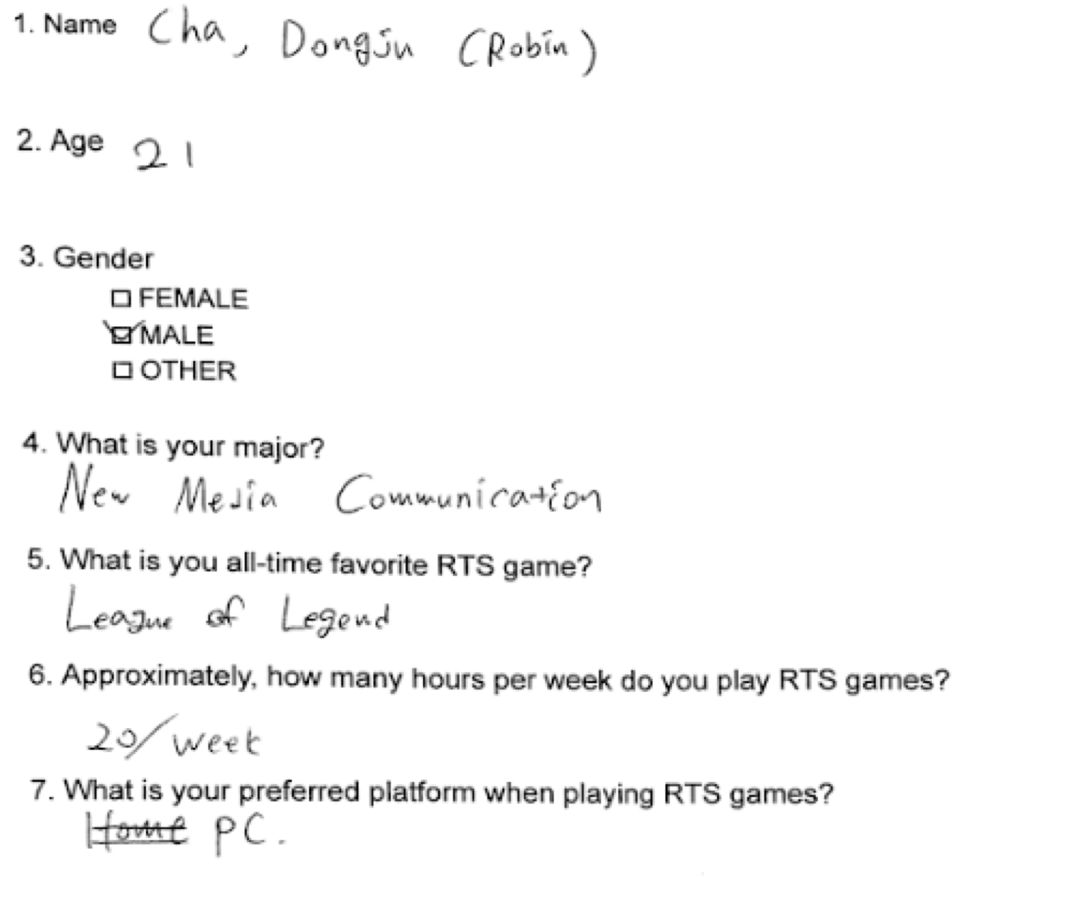

His favorite game—League of Legends—is one of the first RTS games. He is also a heavy gamer, investing about 20 hours a day towards gaming. We call him **Participant 1** and use his data to primarily report on out RQs. His verbal and non-verbal (interaction) data [raw data] is attached as **Participant1_transcript.doc** and his video is attached as **Participant1.mp4**.

Observer#1 explained the task and conducted the study primarily. Observer#2 took observation notes. Participant 1 could not successfully explain the agent’s behavior. He thought like a true gamer, looking for life points.

To him the graph’s negative rewards didn’t make sense. He thought hitting the big enemy is easier and is supposed to produce more points. But it doesn’t. He tries to explain that, this must mean that the small enemy has a bigger life point. To him, the magnitude of the rewards mattered more than the positive or negative rewards.

## **An exhaustive inventory of the elements we discussed in class**

### The people in the space

#### 1. Who are they, what are they like?

The study was conducted on the first floor of OSU’s Valley Library. Most people around were students. It is hard to tell what major/degree they are pursuing since it was a common area. They were from various age groups and ethnicity.

#### 2. What are they doing?

The place where the study was conducted is primarily used by students to access printing equipment and computer resources. There were PCs placed in cubicles where students were using various online resources.

#### 3. How are they doing it?

The printers were on one side of the room, and often students were leaving their cubicles to walk up to the printers. There were students constantly walking in and out of the area. Most of them were focused on their screens for a significant time.

#### 4. What do their emotions, purposes, reactions seem to be?

Half of the people seemed very focused on the task they were performing – downloading or using online books – and rarely noticed us. The other half were frustrated with printers or were distracted and looking/walking around the room to find people (maybe their group mates)/places to sit.

Another person, seated on an open table (similar to ours, there were two open round tables in between the printers and the cubicles) beside us, stared angrily at one of the observers and the participant for a long time. Maybe, our activity was distracting him from his task (he had his laptop).

#### 5. What problems do they encountered with their activities?

One person using the printer directly behind our participant who seemed very frustrated with the device and was violently crumbling the printouts and tossing them into the trash-bin repeatedly.

The other people seemed to be mostly deciding where to go or struggling to find someone/some place.

The area had normal noise levels – like a coffee shop – and this might affect the ability to concentrate for some people.

### The objects (technological and otherwise) in the space and with the people

#### 1. What are the functional elements of the objects?

Computers(PCs) used to access online library and any other online resources. Printers, scanners and copiers – this area is the designated common printing area for the OSU students.

#### 2. What are the decoration elements?

Tables, chairs, clock, windows, doors, cubicles etc.

#### 3. Which objects do people look for (perhaps to somehow interact with)?

Computers that are free for them to use, printers to print/scan, whiteboard to discuss in groups, open places to sit etc.

#### 4. Which objects do people bring with them that matter to the activities they are trying to do?

Laptop, papers, pencil, headphones, backpacks (most of them stay here temporarily).

### The environment: spaces, architecture, lighting, etc.

#### 1. What is the layout?

The layout overall is expansive, and mainly consists of squares such as tables, chairs, and computers. The environment is bright.

We used the table (in pic with 2ladies: one in yellow, other in red) and Participant 1 was seated in the red lady’s chair. Whereas, Observer#1 and #2 sat on the two adjacent chairs.

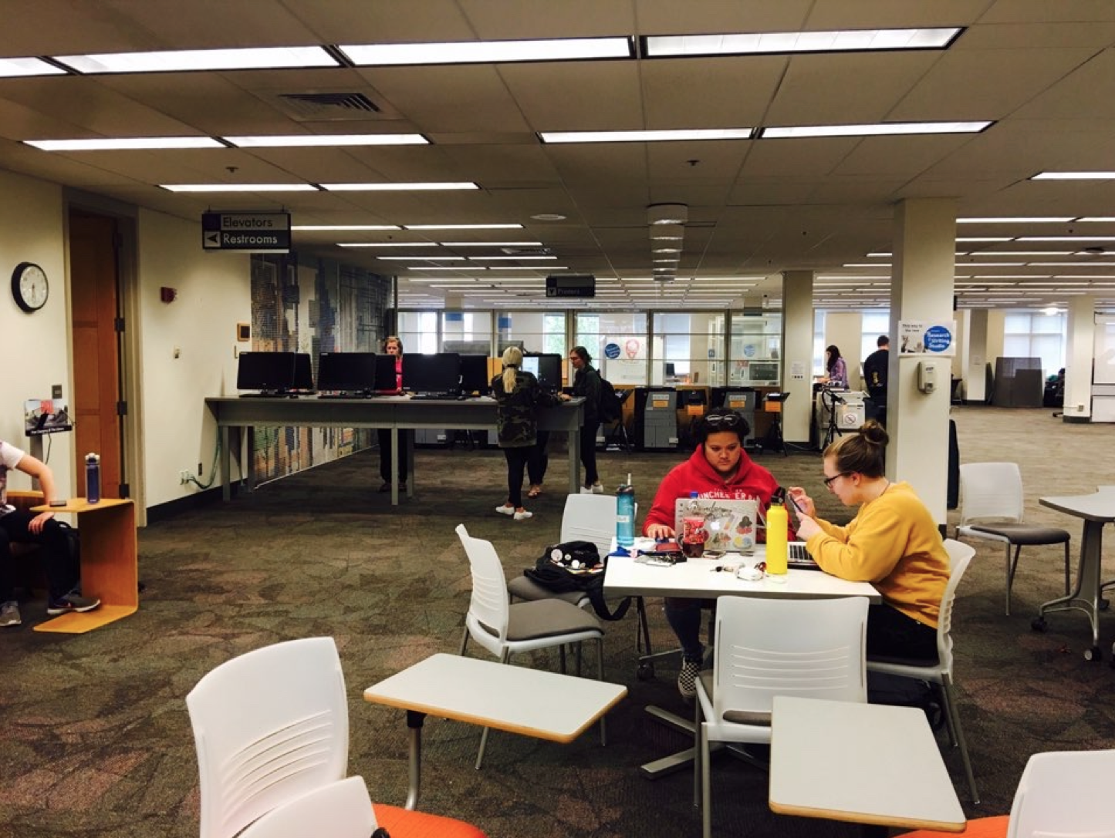

#### 2. What is the environment like?

The environment is like a common area; very expansive, and a portion of the area has cubicles for a private space with PCs in them. There were printers and people would visit them frequently. There were open tables for multiple students to sit as well as just for individuals.

#### 3. How does it influence the activities people engage in?

Its expansiveness may support people who are interacting with each other freely while it can be somewhat of a bother the other who are working individually since the noise could spread. The bright environment definitely supports people reading or writing stuff. In other words, it helps people study.

#### 4. How does the environment support the objects above?

First of all, the environment supports people finding the objects they are looking for very well. The functional objects (computers, printers, scanners, and copiers) are placed in the middle of the environment, which helps people to access them easily. PCs connected to printers do not have chairs but standing desks only. It makes people finish their stuff quickly and leave, so other people can use it in fair time.

## **Attach your raw data: detailed observations (verbal and non­verbal)**

See file **“Participant1_transcript.doc**” and **“Participant2_transcript.doc”.**

## **With the detailed observations, point out the places that provide Results/Insights and say what they are (“I”)**

### **What are the answers to your research questions?**

Our research questions are:

1. RQ1: How do users interpret time-based elements?
   1. **Blue diamond as a play head:****(BUG#2, T&T#1)**

Participant 1 did not find the blue diamond to be clickable on their own and even after observer 1 told him to “click,” the participant still tried to drag it to the right. Concluding, the participant did not perceive the explanations timeline to be a timeline of different data points, but rather a timeline of more minute points where the blue diamond was the play head.

*(See 3.a below for transcript)*

* 1. **Did not see the timelines were elements that could be interacted with: (BUG#53, Obs)**

Participant 1 nearly gave up looking for more information and randomly clicked the interface 27 times before intervened by observer 1 [1:37 - 2:52]. Ironically, participant 2 also clicked the interface 27 times before being intervened by observer 1 [1:00 - 2:45]. This shows, by **triangulation**, that the timelines are hardly noticeable by users.

* 1. **Graphs containing a time element:**

Participant 1 interpreted the saliency maps and graphs as being live elements that would change as the game progressed, i.e. continuous saliency maps. However, this is not the case. The user can be seen selecting “Attack top_left” and then clicking the play button hoping the outcome changes or the maps change in **Participant1_transcript, 03:25:**

*“[Selects the option for Attack top_left, plays the replay file, deselects Attack bottom_left]*

*[Participant is confused, puts hand over mouth, shakes his head.]”*

* 1. **Cannot tell when the replay ends:**

Participant 1 cannot tell when the replay ends. He does not perceive the time bar (steps timeline) to be a timeline. This can be seen in **Participant1_transcript, 01:06:**

“**Participant:**

is that all?!”

1. RQ2: What information does the user find helpful when trying to explain the agent’s behavior?
   1. **Total Rewards Per Action graph:**

The graph were instrumental in the participants figuring out the agent’s decision. Participant 1 looked at the sheer size of each element in the bar graph regardless of its positive or negative value and determined the top_right component of the game map was a “boss.” For **triangulation**, participant 2 looked at which action had the highest (most positive) reward.

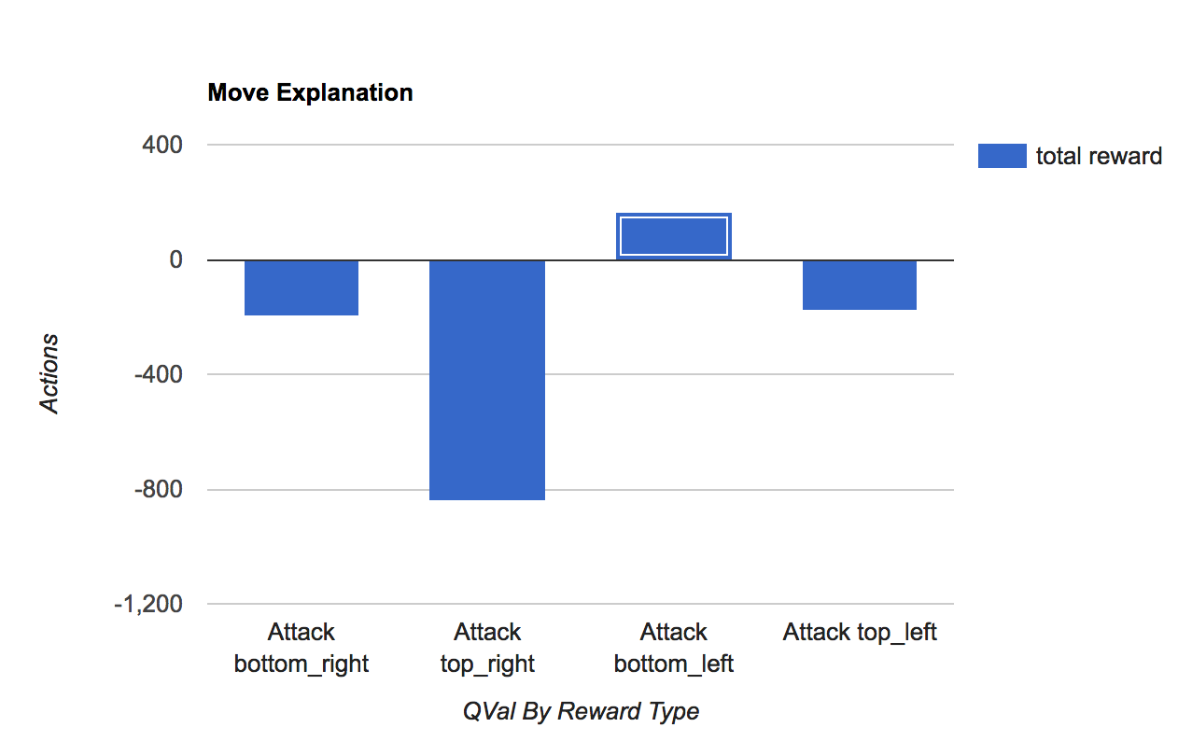

***Figure 1: Participant 1 looked at the raw size of each graph element whereas participant 2 looked at the greatest total value.***

* 1. **Color and size of the tower (components) on the game map: (BUG #28, 17, 32)**

Participant 1 took the information gleaned from 2.a and looked at the game map and determined the top_right component of the game map was a “boss.” He also inferred from the colors that the red was the enemies and the blue were friends, which is incorrect.

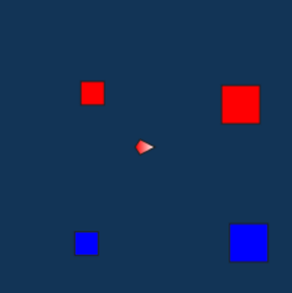

***Figure 2: Game map***

* 1. **Specific Rewards Per Action graph:**

Participant 2 used the “Specific Rewards Per Action” graph (Figure 3) to determine the agent’s intentions. He looked at the legend on the right-hand side to determine killing the smallest enemy would be most logical thing to do.

See **Participant2_transcript, 04:13:**

“**Participant**:

Okay, so the simulation obviously has all the information I can see so it would attack the one with the high success rate and the highest reward to success, which it did so that's that's a logically thinking system, [Laugh].”

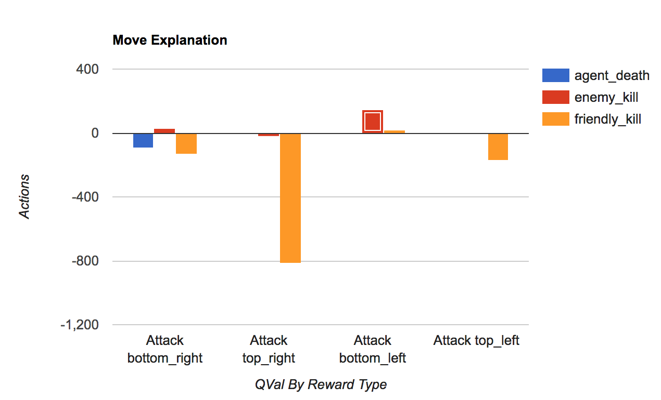

***Figure 3: Specific Rewards Per Action graph***

* 1. **Specific Rewards graph, bar height confused Participant 1 what ‘friendly_kill’ means. [This is because, there is no concept of friendly fire in Participant 2’s favorite RTS game].**

Participant 1 didn’t understand the graphs were talking about which target gave the most reward. He didn’t understand the concept of getting a reward, even if negative, for attacking a friend. This is assumed because the participants favorite RTS game (League of Legends) doesn’t have the concept of “friendly fire” meaning you cannot harm your friends in that game.

Participant 1 also noted that it doesn’t make sense that these graphs were displaying rewards as seen in **Participant1_transcript, 6:30:**

**Participant:**

Reward as score? Oh... I see...

but I just personally think… if it's the score… It doesn’t make sense.

Because like the big one… is much easier to target it.

But when you get the big one… You [should] get a much larger point, it's not make sense.

Like I guess the small one supposed to be have a large points… than the big one.

So like I just personally think that’s [the graph] not… uhm… points…

[Instead it is] how important or life point or that kind of stuff, ah....

*[pause for 10 secs]*

hmm...only this one [top right_Big red]… this guy…

The things what I'm confused is like

Everyone has a [Points at the blue bars on Total Rewards graph, for attack options other than top_right]…

Seems like… pretty… like have a similar “life point” or something

But this one [bar for Attack top_right] only got like… tons of like…

I don’t know… it's weird. But maybe this one would be boss of the game or something... I'm not sure about it.

1. RQ3: What elements of the UI does the user struggle with during the workflow?
   1. **The Blue Diamond: (BUG #1, 2, 14)**

Participant 1 did not find that the blue diamond could be clicked to obtain more information. Even when given a hint – to “click the blue diamond”, Participant tries to drag This can be seen in **Participant1_transcript, 02:42:**

**Observer#1:**

Alright, I'm gonna give you a hint.

**Participant:**

Okay. *[Leans back into the screen]*

**Observer#1:**

Okay, try clicking on that blue diamond.

**Participant:**

*[Tries dragging the blue diamond twice from left to right]*

**Observer#1:**

Alright, just clicked on it.

[Participant clicks on the blue diamond, information appears on the UI]

There you go!

**Participant:**

Ooooooh, that's cool.

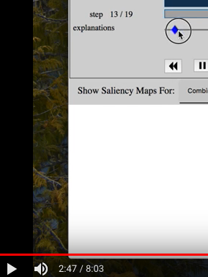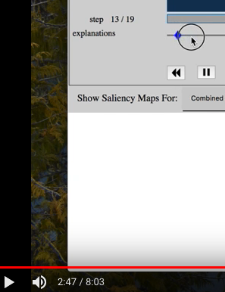

***Figure 4: Notice at 2:47 Participant 1 tries to drag the diamond for the first time.***

This shows that, the blue diamond is not only an effectively invisible element. But, the affordance is also confusing. Even when they are told how to use it, they still try to click it

To **triangulate,** we observed how Participant 2 behaved. When Observer#1 told him to click on the blue diamond, he tried to drag it once and then he clicked it. **Participant2_transcript, 02:40:**

“**Observer#1:**

Alright, I'm gonna give you a hint. try clicking on that blue diamond

**Participant:**

[Tries dragging blue diamond once, then clicks it]

Oh Shite!”

* 1. **Replay files:**

Participant 1 struggled a lot with the replay files. He first accidentally changed the replay file trying to find more information, and got very confused when the game turned into a blue screen trying to load the new replay file. This can be seen in **Participant1_transcript, 01:35:**

*“ [Clicks on the Replay file dropdown menu, selects third one. Game window becomes blank blue, and a new game loads]*

Oh! I, I, Whatever... [*Expression changes to surprise, fear on seeing blue screen, ignores issue when he saw all the red and blue boxes reappear]*

I don't know. *[Clicks pause button twice, game plays]”*

To **triangulate**, we inspected Participant 2’s video. Contrarily, he hovers over the replay file dropdown menu once in the beginning, but never changes the replay file.

* 1. **Struggle to understand and explore Saliency maps**: **(BUG #5)**

Participant 1 spent some initial time trying to explore Saliency maps. But after a couple of interactions, he gives up. This can be seen from **Participant1_transcript** where we only observe Participant 1 interacting with Saliency maps for about 1 minute around **03:54**. He also misinterprets the selection menu for saliency maps as a menu to see a different attack in the replay file.

To triangulate, we observed how Participant 2 behaved. Participant 2 spent a considerable of time exploring Saliency maps. He even selected multiple options from the saliency menu. However, he did not notice that there were more saliency maps that can be accessed by scrolling left to right, until Observer#2 pointed it out to him. This can be seen in **Participant2_transcript, 04:48:**

“O**bserver#2:**

You can actually scroll... there are more maps to the right. “

* 1. **Interpreting the graphs:**

Participant 2 struggled to interpret the graph. The graphs had very little textual information. The legends and axes are all labelled in a way one normally names variable in a code. This can be seen in **Participant1_transcript, 04:36:**

**Participant:**

The, the orange one [friendly_kill bar]. Is that what… my friends kill their enemies

Also, **Participant1_transcript, 04:36:**

**Observer#1:**

you know you can think of the reward as a score.

**Participant:**

Reward as score? Oh... I see...but I just personally think… if it's the score… It doesn’t make sense.

Participant 1 proceeded to explain the graph in terms of life points, stating that the one with the bigger bar must have the highest life points. On the contrary, Participant 2 had no issues understanding and explaining the graph, stating that the agent behaved to have minimum friendly kills and maximum enemy kills (which is the correct explanation). See **Participant2_transcript, 04:48**

“well attacking.. it attacking a friendly well... doesn't make any sense at all. Attacking an enemy you want to attack the smallest enemy with the highest possible rewards... which is that one [small blue tower] ... so.”

* 1. **Interpreting components on the map:**

The task prompt mentioned what the game was about, and what each element on the game represented. However, Participant 1 mistook the big red square as an enemy capable of attacking. As seen in **Participant1_transcript, 04:36:**

**Participant:**

so it is that mean this one [top_right Big Red] got attacked or this one [top_right Big Red] try to attack some else

**Observer#2:**

Yeah. Because the red is the friend…

**Participant:**

Oooooooh! Okay.

* 1. **Unable to discover more sets of Saliency maps if scrolled down**: **(BUG #9, 10)**

Participant 1 did not discover that there were additional sets of saliency maps when multiple options were selected from the Saliency Menu. This was due to Gestalt Principle, where his screen smoothly cut-off at a point where the first set of Saliency maps end (Shown below).

When he selected more than one options, less than half of the titles for the saliency maps were visible. It was too little to grab his attention. As a result, he never scrolls down to see those maps.

To **triangulate**, we observed what Participant 2 did. Even though in Participant 2’s case a little more text was visible, even he failed to notice the additional set of Saliency maps below. See **Participant2_transcript, 02:40.**

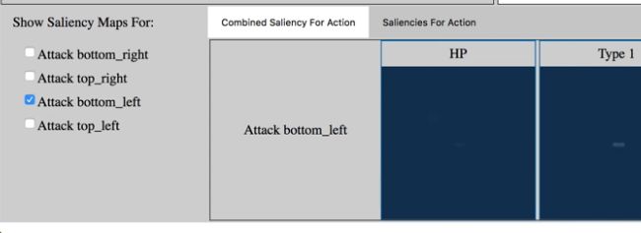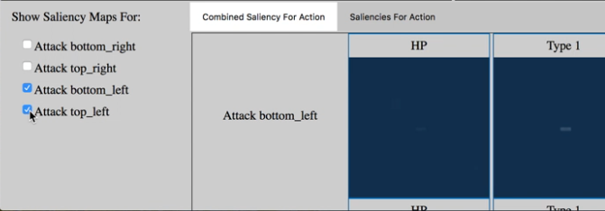

Both didn’t know that there were more sets of saliency maps if they scrolled down. (Gestalt… continuity, the UI’s first screen only significantly shows one array of maps, the change is not visible when multiple attacks are selected)

* 1. **Misinterpreting the selection menu for the Saliency maps**: **(BUG #2)**

The selection menu for saliency maps was interpreted as options for what the agent would attack in the game. Participant 1 would select attack top_left options and replay the game hoping that the agent would attack the top_left (big red) instead of the normal game i.e. he hoped that this menu would somehow change the replay file.

This is seen from **Participant1_transcript, 02:42:**

“Attack bottom_left…!! *[ Reads text from left side selection menu for saliency maps]*

*[Selects the option for Attack top_left, plays the replay file…]”*

### **What other insights did you get from this that are relevant to your "patient"?**

* 1. **Lack of details of the game replay:**

The game replay in the UI contains no information about what the elements/purpose of the game is. The usual RTS games have more visual and textual information about the components, the mission and progress of the game. It is hard to relate to just squares and triangles in the game in the UI and make any sort of connection to their mental model of RTS games.

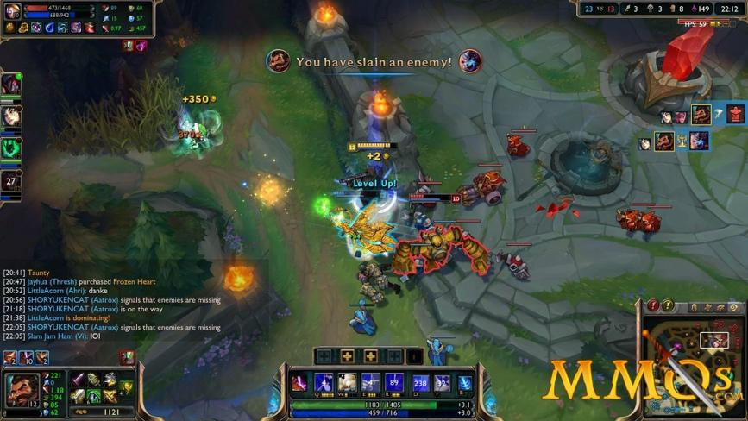

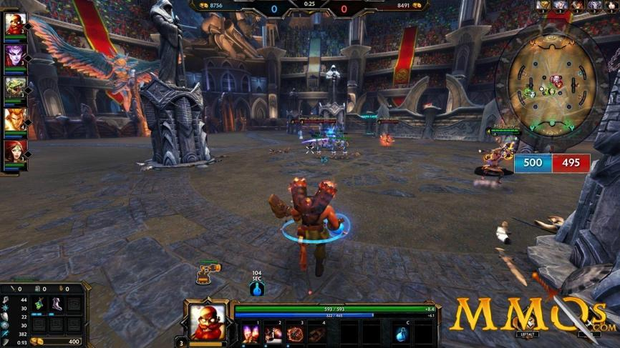

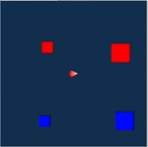

***Figure 5: From top to bottom - League of Legends, Smite and 'Patient' game. Difference in level of details that can be obtained from just looking at the gameplay.***

This difference in details affects users understanding of the properties of the objects. Eg. It is seen in **Participant1_transcript** around **04:36**

“Why you attack each other?”

where he thinks of the squares as enemies instead of towers.

It is also observed in **Participant1_transcript** around **05:12**

“so it is… that means this one[top_right Big Red] got attacked or this one [top_right Big Red] try to attack some else?”

where he thinks the boxes, which are actually towers, can also attack.

* 1. **Magnitude of graphs and Life points:**

Participant 1 was thinking like a true gamer – in terms of “life points” or health points that are associated with elements in a general RTS game. Due to that, the difference in magnitude of rewards caught his attention more. He completely ignored if the reward was positive or negative. Instead he focused on why only one of the bars was significantly bigger than the others. He interpreted the graphs magnitude to be related to health/life points.

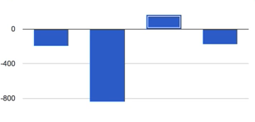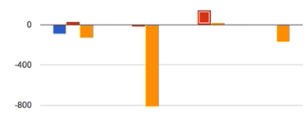

***Figure 6: Only the second bar was very different, the other 3 had similar rewards. The second bar corresponded to the Big Red box in the game. This confused the participant.***

This behavior is seen in **Participant1_transcript** towards the end, where he is trying to explain

“Everyone has… Seems like… pretty… like have a similar life point or something. But this one only got like… tons of like…maybe this one would be boss of the game or something...”

* 1. **Too many options in the selection many for saliency maps: (BUG #8)**

The selection menu for Saliency maps changes when the rewards tab is changed. When the “Total Rewards” tab is selected, there are only 4 options. But when the “Specific Rewards” tab is selected, there are 12 options. (Shown below)Both Participants struggles to understand the meaning of the longer saliency selection menu for specific rewards tab. None of them scroll down to access the other options in the second (right) figure.

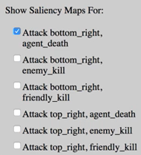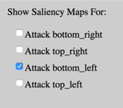

***Figure 7: (left to right) Saliency maps options for 'Total Rewards' and 'Specific Rewards'. Users did not gain any additional information, even after spending time by selecting multiple option****.*

Participant 1 immediately moved back to Total Rewards tab, indicating that it might be too much information. It is observed in **Participant1_transcript:**

*“*

*[… clicks on specific rewards tab, moves pointer to the left side menu under saliency maps]*

ohhhh!!! *[Notices that saliency map selection menu is different]*

*[Switched to Total Rewards tab, switches to Saliencies for Action Tab and scrolls across the different maps... ]* “

Participant 2 **(triangulation)** on the other hand selected and deselected multiple options from the second figure, but never scrolls down to truly explore different options.

See **Participant2_transcript, 02:40**

* 1. **Absence of concept of friendly fire in favorite games – User struggles with graph label “friendly_kill” (BUG #3)**

The phrase “friendly_kill” caused a great deal of confusion in Participant 1. This can be seen in **Participant1_transcript**:

*“ Friends_kill….???... The, the orange one. Is that what… my friends kill their enemies”*

This inspired us to investigate what friendly fire meant for his favorite game. Turns out, Participant 1’s favorite game – League of Legends – does not have the concept of friendly fire.

**To triangulate**, we looked into Participant 2’s favorite game – Smite. Smite does have the possibility to cause damage to your friends, and sure enough Participant 2 did not have problem understanding friendly kill and explaining it.

From **Participant2_transcript, 04:48:**

“well attacking.. it attacking a friendly well... doesn't make any sense at all. Attacking an enemy you want to attack the smallest enemy with the highest possible rewards... which is that one [small blue tower] ... so.”

* 1. **Saliency maps don’t add any valuable information:**

Participant 1 spends some time exploring saliency maps, but doesn’t refer to saliency maps when trying to explain agent behavior at all. See: **Participant1_transcript**, last page.

This pointed to the fact that Participant 1 did not gain any information from the saliency maps. To **triangulate**, we investigated Participant 2’s interaction with saliency maps.

Participant 2 explains agent behavior twice during the study. The second time with slightly more information. He provides the same graph(only) based explanation **before and after** spending more than 2 minutes exploring the saliency maps.

From **Participant2_transcript, 04:13,** before exploring Saliecny maps**:**

**“**I can see so it would attack the one with the high success rate and the highest reward to success, which it did so”

and from **Participant2_transcript, 04:48:**

“well attacking.. it attacking a friendly well... doesn't make any sense at all. Attacking an enemy you want to attack the smallest enemy with the highest possible rewards... which is that one [small blue tower] ... so.”

This concludes that users don’t gain any additional information about agent behavior from saliency maps.

* 1. **Tabs were inviting dead ends (BUG #9) – making users believe clicking on tabs produced more information:**

The use of tabs was unusually high. Participant 1 clicked the 4 available tabs(Shown below) more than 40 times during the entire study of 8:03 minutes. He clicked the tabs even before clicking the blue diamond i.e. he switched tabs even when none of the tabs had any content.





***Figure 8: The 4 tabs (top to bottom) for Saliency and Graphs.***

To **triangulate**, we looked into Participant 2’s interaction with the tabs. He, too, clicked the tabs more than 30 times in 6:15 minutes of study.

This led us to conclude that the tabs were the most visible elements, that gave the wrong impression to the users that they can gain more information just clicking on the tabs.

Participant 2 even states his motive of gaining information by clicking the tabs numerous times. In **Participant2_transcript, 01:25**:

“[Small chuckles] I feel like I'm just being really stupid and these things are not actually supposed to react or this is actually supposed to show information that I can't actually see. [Frustration, frowning]”

# 

# Chapter 4 - Gestalt, Design, & Tenets/Trap Principles

In class activity using Gestalt, Design Principles etc. extended to cover Scenarios from Chapters 2 and 3.

## Gestalt Principles

### Proximity

* Positive examples
  + The columns and rows for the saliency arrangement are a positive example of proximity. The spatial grouping of these elements allow Jake to understand that they are in some way related.
  + The grouping of selection for the saliency maps (bottom left)
  + The proximity of the time steps and the explanation bars infer that these two things are related. This is a positive example of proximity.
  + The time control grouping allows us to know that they are related.
* Negative examples
  + The region around the time step bar does a poor job of grouping (BUG #14)

### Similarity

* Positive examples
  + The shape of the reward decomposition graphs (rectangles) does a good job of presenting a similar geometric arrangement to allow Jake to infer that they are, in some way, related.
  + The saliency maps do a good job of showing Jake that a similar kind of information is being presented to him.
  + The coloring of the objects, such as the broken down reward decomposition graph, does a good job of showing Jake the relativity between actions and their reward acquired
* Negative examples
  + N/A

### Figure/Ground

* Positive examples
  + Highlighting of selected decomposition bar (also a design example of feedback) allows for Jake to know which bar has been selected.
  + Tabs in the saliency and reward decomposition (one is grey, and the other is white) allow Jake to know which type of information he is viewing.
* Negative examples
  + The replay: tab that is highlighted at the top to the left of the drop-down menu gives the impression that this is a highlighted object (not the case). (BUG #15)
  + The reward decomposition background is white, making it appear selected or highlighted, whereas the saliency background is grey, which makes it appear like it is in the background. (BUG #16)

### Closure

* Positive examples
  + The salient pixels, although they do not form a whole shape, allow for Jake to close them and create the necessary pixels that exist on the map. For example, not *all* pixels from the big towers are highlighted, but Jake closes them to recognise that the agent was generally looking at the big towers.
* Negative examples
  + Due to the sparse nature of the information interface, there are no negative examples of closure at this time. (BUG #17)

### Continuity

* Positive examples
  + The timeline (step 1/N) allows jake to know how far in the replay he is. This is also an example of external consistency, since the likes of YouTube also contain this feature.
  + The decision points interrupt a line, though Jake can infer that this is still a whole line.
* Negative examples
  + Figure UI gives the impression of having reached an end, even though there are more rows below. A solution to this could be a scrolling bar on the right hand side, since the only currently available solution is to zoom out of the interface, making the information more difficult to understand. (BUG #18)
  + The current implementation of the UI shows that there is information to the right of what is currently available.  Similarly to the example above, a scroll bar could be implemented (BUG #19)

### Symmetry

* Positive Examples
  + The saliency channels are a positive example of symmetry, since we perceive that a long rectangle is broken down into 6, smaller squares.
* Negative Examples
  + This UI does not demonstrate any examples of negative symmetry, since there exists no complex shapes to break down into smaller, comprehendable elements. (BUG #20)

### Common Fate

* Selection of reward decomposition highlights the relevant saliency map
* Blue diamond selection reveals the information
* Selecting the color on the legend selects the bars on the chart
* Play button and the game (when played, game goes. When paused, game stops)
* Steps increase, and the bar fills up as the game progresses.

**\*\* poor feedback: when clicking graph to load specific saliency maps, the wrong tab for the saliency gets highlighted.**

## 

## 

## Tenets and Traps

**#2 Effectively Invisible Element**

Blue Diamond : Even though users can see that there is a blue diamond, it does not clickable. (BUG #21)

**#4 Uncomprehended Element**

Blue Diamond - Even though users can see that there is a blue diamond, its meaning is unclear. (BUG #22)

**#5 Inviting Dead End**

Clicking taps for rewards graph or saliency maps before activating blue diamond does not work right. Clicking blue diamond should be preceded for that. (BUG #23)

Clicking home button ‘SCAII’ does not give feedback (BUG #35)

**#6 Poor Grouping**

The list of actions of saliency maps has poor grouping in it. Such order corresponds the order of actions on Specific Rewards Per Action, but the actions on the list are not grouped/chunked regard of it. (BUG #24)

**#7 Forced Syntax**

The order of actions in the graph may not very natural to users; bottom_right, bottom_top, bottom_left, top_left. (BUG #25)

The red color usually represents enemy, but in XAI, red tower is friend (BUG #38)



**#8 Memory Challenge**

Users may need to remember which tower is friend or enemy. (BUG #32)

Users may need to remember the position of the tower that is attacked by player in textual form to find the appropriate saliency maps for the action such as Attack bottom/tom_right/left_enemy/friendly_kill. (BUG #33)

**#9 Feedback Failure**

Clicking taps for rewards graph or saliency maps before activating blue diamond does not work right. Clicking blue diamond should be preceded for that. (BUG #34)

Clicking home button ‘SCAII’ does not give any feedback (BUG #35)

**#10 Physical Challenge**

-- NA

**#11 Accidental Activation**

-- NA

**#12 Slow or no response**

**--NA**

**#13 Captive wait**

The user cannot revert back to their previous state because browser controls are not enabled. However, when trying to reload, the UI crashes. Not allowing the user to get back to where they were. User is forced to kill process and relaunch app. (BUG #39)

**#14 Unnecessary Step:**

Having to click the BD to gain more information. If the purpose of the UI is to provide information to the user, why hide it until a button is clicked? (BUG #26)

**#15 System Amnesia:**

Remembers the last clicked Decision Point, and even when BD is unclicked, clicking on the graph tabs can pull up the graphs from the last DP (BUG #27)

**#16 Information overload:**

BD. People are frustrated for a long period of lack of information. But right after they click on blue diamond, waaay too much info pops up. (BUG #28)

**#17 Bad Prediction:**

Clicking on the graph legend yellow, highlights all yellow bars in the graph. The user might be clicking on the legend to learn what the legends mean. (BUG #29)

**#18 Irreversible action:**

User can’t reload the interface.       (BUG #30)

**#22 Variable outcome:**

When reloading a new replay file, there are rewind buttons and pause buttons when the video is paused. But when the UI first loads with the default file , there are rewind and play buttons when the video is paused. (BUG #31)

**#26 Unattractive Appearance:**

The UI has a generally unattractive appearance (BUG #36)

**#25 Ambiguous Home:**

No single place to return to. (BUG #37)

**#24 Inconsistent Appearance**:

Graph color is red for enemy_kill, tower red is friend. Inconsistent! (BUG#38)

## Design Principles

### Affordances

* Pixels look clickable, so the towers look clickable (BUG #40)
* Time controls looks clickable
* SCAII title looks interactable (BUG #41)
* The “Replaying:” region looks clickable (BUG #42)

### Feedback

* Minimal feedback from the blue diamond (noticeable/comprehendable) (BUG #43)
* Play button turns to pause
* Time bar ‘fills up’ after each step
* time control blue border for last item clicked
* Pause button freezes (BUG #44)

### Constraints

* ← & → buttons greyed out (in the browser)
* Refresh button breaks the system (BUG #45)
* Once the blue diamond is selected and deselected, the maps still pull up from before (BUG #46)
* Once pause button is clicked, you can’t click on the pause button again

### Consistency

* Actions in a non-intuitive order (BUG #47)
* Graph bar actions from left→ right reads attack bottom-right → top-left. Opposite order of reading the graph. (BUG #48)
* Graph legend colours contradict enemy/friend colours (BUG #49)

### Visibility

* Blue squares on a blue background (BUG #50)
* Red not historically associated with friend (BUG #51)
* Hard to relate graph label to towers on the map (BUG #52)

## Prioritized Bugs:

Note: For quick reference, see all bug list below

1. The blue diamond timeline is invisible (T&T #1; BUG #2)

2. The blue diamond timeline is uncomprehended (T&T #4; BUG #3)

3. The labeling of the timeline is a bit misleading (BUG #9)

4. Timeline proximity to step counter (Gestalt principle: proximity; BUG #14)

5. Different approaches to see saliency information (T&T #7; BUG #11)

6. White vs. grey background for saliency information vs graphs (Gestalt principle: internal consistency; BUG #16)

7. Order of actions in the graph may not be very natural to users (T&T #7; BUG #25)

8. People are frustrated from long periods of a lack of information, but when it shows up, oh boy does it show up… (T&T #16; BUG #28)

9. Inability to scroll down to see more rows of saliency (T&T #5; BUG #18)

10. Inability to scroll sideways to see more columns of saliency (T&T #5; BUG #19)

11. No single place to return to (T&T #25; BUG #37)

12. Graph color is red for enemy_kill, tower red is friend. Inconsistent! (Gestalt principle: internal consistency; BUG #38)

13. Clicking rewards graph or saliency maps before activating blue diamond doesn’t work (T&T #5; BUG #23)

14. Having to click the blue diamond to gain more information (T&T #14; BUG #26)

15. Red not historically associated with friend (Gestalt principle: external consistency; BUG #51)

16. Hard to relate graph label to towers on the map (Gestalt principle: proximity; BUG #52)

17. Remembering color for friend or foe (T&T #8; BUG #32)

18. No feedback to see if continuous saliency maps are actually possible (T&T #9; BUG #7)

19. No information for the user about how to advance through the system over time (BUG #10)

20. No information about cost v. benefit for using the play button (T&T #9; BUG #12)

21. Clicking home button ‘SCAII’ does not give feedback and does nothing (T&T #5; BUG #35)

22. Path through the task for process-oriented learners not there (Heuristic Evaluation: learning style; BUG #8)

23. The only dynamic time information is given by ‘steps’ – bad for information processing style (Heuristic evaluation: information processing style; BUG #4)

24. Clicking on the graph legend highlights all bars of that type. User might click on legend to learn what the legend means (T&T #17; BUG #29)

25. 33 Which action maps to which region of the game map (T&T #8; BUG #33)

26. Actions in an unintuitive order (BUG #47)

27. Graph bar actions from left right read poorly (BUG #48)

28. Graph legend colors contradict enemy/friend map colors (Gestalt principle: internal consistency; BUG #49)

29. Unattractive Appearance (T&T #26; BUG #36)

## All bugs listed throughout Chapters 1-4:

Note: Some are labeled as “NOT A BUG” these are left so the numbering of our bugs stays consistent

1. Tabs have word ‘Saliency’ in it which user doesn’t understand (T&T #4)
2. The blue Diamond timeline is invisible (T&T #1)
3. The blue Diamond timeline is uncomprehended (T&T #4)
4. Having to click the blue diamond is Forced Syntax (T&T #7)
5. The only dynamic time information is given by ‘steps’- bad for info processing style (HE Info Processing)
6. There is no feedback when trying to see if using play button causes maps to change (T&T #9)
7. No feedback to see if continuous saliency maps are actually possible. (T&T #9)
8. Path through the task for process-oriented learners not there (HE Learning)
9. The labeling of the timeline is a bit misleading
10. No info for the user to know that user can advance through time to see how the system changes
11. Different approaches to see saliency information (T&T #7)
12. No information about cost vs. benefit for using the play button (T&T #9)
13. No saliency information as agent moves (T&T #9)
14. Timeline proximity to step counter (Gestalt Proximity)
15. Replay word highlighted (Gestalt Figure/Ground)
16. White vs. grey background for saliency information vs. graphs (Design Consistency)
17. Due to the sparse nature of the information interface, there are no negative examples of closure at this time. (NOT A BUG)
18. More saliency below window (T&T #5)
19. More saliency to the right of window (T&T #5)
20. No negative examples of symmetry (NOT A BUG)
21. Effectively Invisible Element (Blue Diamond) (T&T #2)
22. Uncomprehended Element (Blue Diamond) (T&T #4)
23. Inviting Dead End (Clicking rewards graph tab or saliency maps before activating blue diamond doesn’t work right) (T&T #5)
24. Poor Grouping (List of actions of saliency maps) (T&T #6)
25. Forced Syntax (Order of actions in the graph may not be very natural to users) (T&T #7)
26. Unnecessary Step (Having to click the Blue Diamond to gain more information) (T&T #14)
27. System Amnesia (remembers the last clicked decision point, and even when BD is unclicked, clicking on the graph tabs can pull up graphs from the last DP (T&T #15)
28. Information overload (people are frustrated from long period of lack of information, but when the information shows up, oh boy does it show up….) (T&T #16)
29. Bad Prediction (Clicking on the graph legend yellow highlights all yellow bars in the graph. User might click on legend to learn what the legend means) (T&T #17)
30. Irreversible action (User can’t reload the interface) (T&T #18)
31. Variable outcome (Initial file play button behaves differently than another loaded file) (T&T #22)
32. Memory challenge (remembering colour for friend or foe) (T&T #8)
33. Memory challenge (which action maps to which region of the game map) (T&T #8)
34. Feedback Failure (clicking tabs for rewards graph or saliency maps before activating BD doesn’t work) (T&T #9)
35. Inviting dead end (Clicking home button ‘SCAII’ does not give feedback and does nothing) (T&T #5)
36. Unattractive Appearance (This UI has a generally unattractive appearance) (T&T #26)
37. Ambiguous Home (no single place to return to) (T&T #25)
38. Inconsistent Appearance (Graph colour is red for enemy_kil, tower red is friend. Inconsistent!) (Design consistency)
39. Captive wait (When using browser reload, UI crashes. User has to relaunch the app) (T&T #13)
40. Pixels look clickable, so the towers look clickable (Design Affordance)
41. SCAII title looks interactable (Design Affordance)
42. The “Replaying:” region looks clickable (Design Affordance)
43. Minimal feedback from the blue diamond (noticeable/comprehendable) (T&T #9)
44. Pause button freezes (T&T #9)
45. Refresh button breaks the system ((T&T #17)
46. Once the blue diamond is selected and deselected, the maps still pull up from before (Design Constraint)
47. Actions in a non-intuitive order
48. Graph bar actions from left→ right reads attack bottom-right → top-left.
49. Graph legend colours contradict enemy/friend colours (Design Consistency)
50. Blue squares on a blue background (Colour wheel)
51. Red not historically associated with friend (Design External Consistency)
52. Hard to relate graph label to towers on the map
53. Did not see the timelines were elements that could be interacted with (Observation)
54. Could not get enough information about the elements on the map (Observation)

# Chapter 5 - Jake wishes to retrieve information about the decision points.

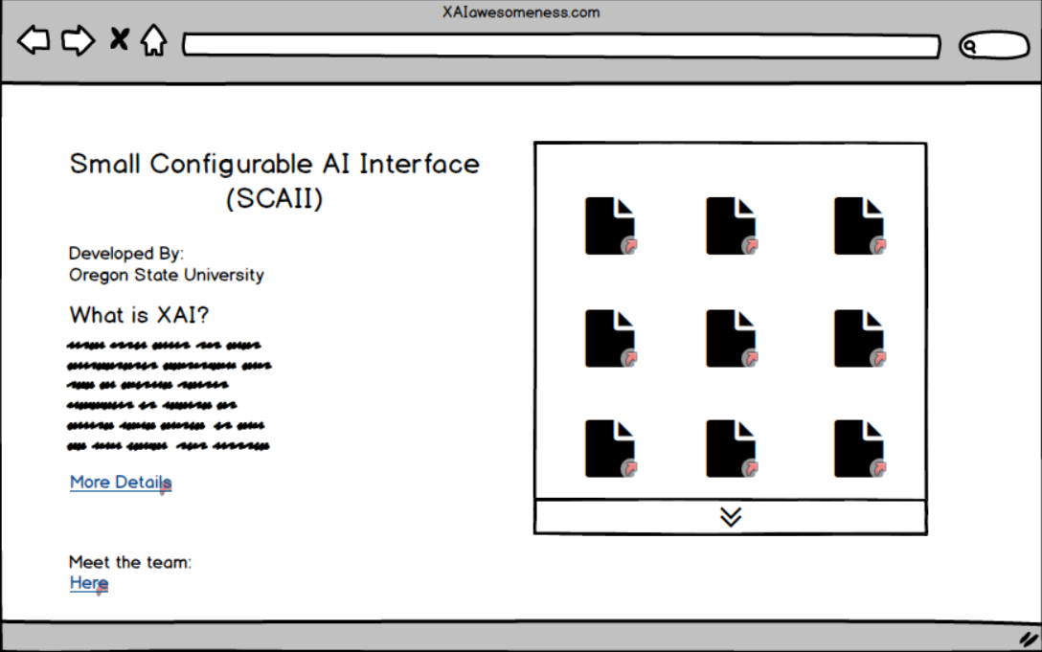

## We found Home

We introduced a home page as the starting page for the users to begin with. This page consists of the different replay files the user can load. This page is also the landing page for information regarding the project. This also is the only page from which users can change the relay files, making it less confusing and redundant.

**Rationale:**

* Observations (Participants interacted with the SCAII to get home)
* Heuristic Evaluation (Information Processing Style)
* Tenets & Traps 25 (Ambiguous Home)
* Design Principle (External Consistency)

**Bugs Fixed:**

**#41 SCAII title looks interactable (Design Affordance)**

**#35 Inviting dead end (Clicking home button ‘SCAII’ does not give feedback and does nothing) (T&T #5)**

**Before:**

When confused or wanting to restart users would often click on the SCAII button which neither was a button nor did it do anything. There was no starting point in the UI.

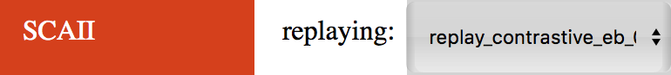

**After:**

We removed the orange tab-like home from all screens and made this page instead. This

prevents the user from getting confused and provides a place to return to.

**#39 Captive wait (When using browser reload, UI crashes. User has to relaunch the app) (T&T #13)**

**#30 Irreversible action (User can’t reload the interface) (T&T #18)**

**#37 Ambiguous Home (no single place to return to) (T&T #25)**

**Before:**

There was no way for the user to return to a base page when they wanted to start over. Often, when learning, the user wanted to abandon the current operation and clicked the browser reload button. That caused the UI to crash.

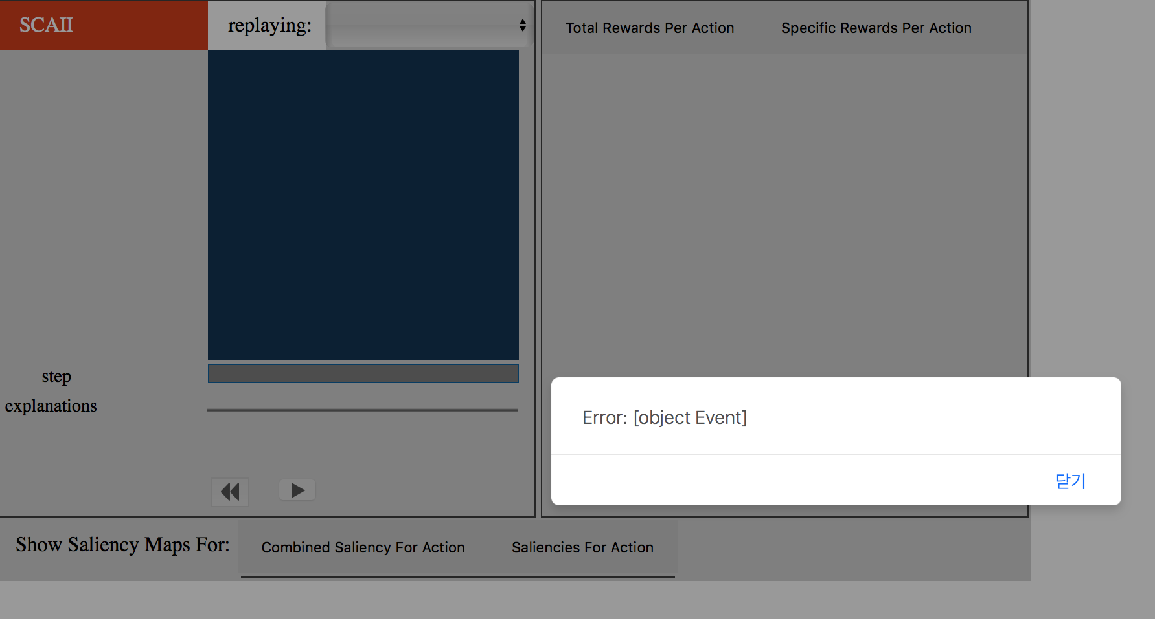

**After:**

We added a Go Home button on each page which would prevent the user from getting frustrated. On clicking the Go Home button the users are directed to this home page where they can start afresh by choosing a replay file of their choice.



**#42 The “Replaying:” region looks clickable (Design Affordance)**

**#15 Replay word highlighted (Gestalt Figure/Ground)**

**Before:**

The way to choose a different replay file was to choose a different name from the drop down menu. This made less sense to the user and created more confusion. Moreover, the region ‘replaying’ looked like a tab instead.



**After:**

We removed the replaying region and instead put all replay files on the home screen. This way,

the user is more sure about what these files mean and do. They can change the files by coming

back to this home page whenever needed.

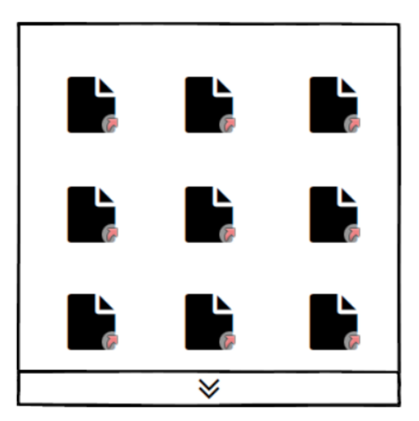

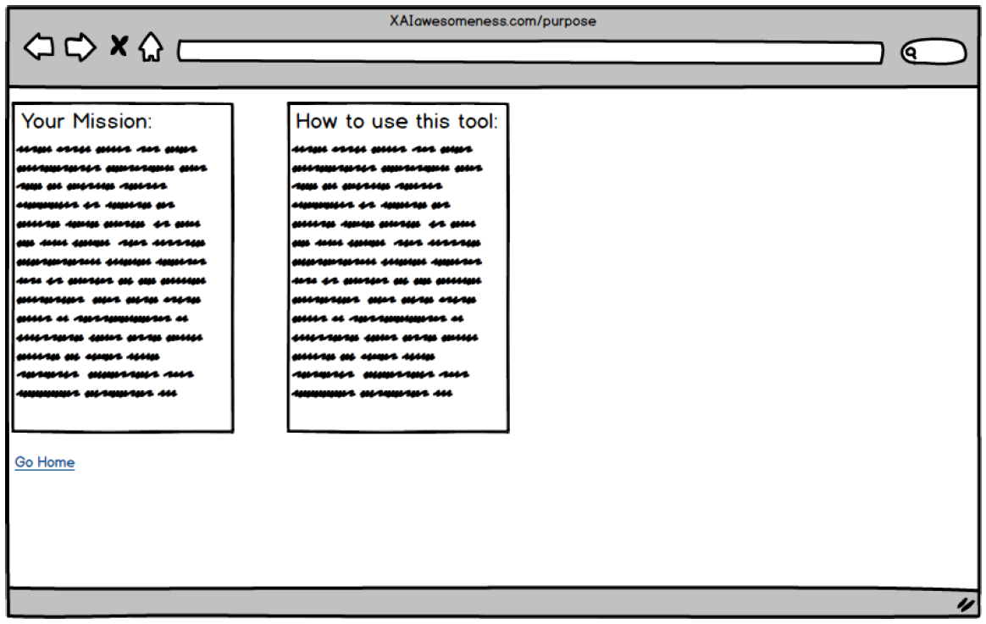

## 

## More Information and Meet the Team

A first time user would always be confused about why the app exists and what the purpose of the UI was. There was no way to gain this information in the previous version of the app. We created this page to provide some explanation regarding the purpose of the app. For a comprehensive learner, this is crucial information.

**Rationale:**

* Observations (They didn’t know what to do with the tool/why it exists)

**Bugs Fixed:**

**#8 Path through the task for process-oriented learners not there (HE Learning)**

**Before:**

Jake being a comprehensive learner wondered what the app was even trying to do. There was no way to gain any information about anything in text from the app.

**After:**

The more information page provides a clear workflow view by describing the user’s mission and directions to use the tool.

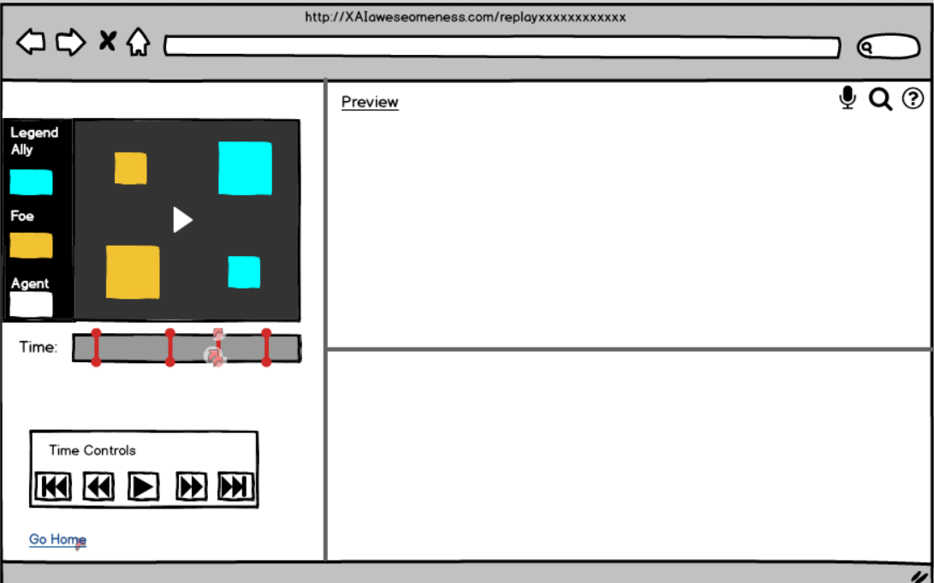

## The Main Screen - Fixing the Blue Diamond

The main screen underwent several changes after our evaluation. The major ones were redesigning the way to access information, time controls, the graphs view, the home button etc. all changes are described in details below.

* Gestalt Principles (Proximity/continuity)
* Design Principles (Visibility)
* Heuristic Evaluation (Learning)
* Tenets & Traps (effectively invisible elements, information overload)

**Bugs Fixed:**

**#2 The blue Diamond timeline is invisible (T&T #1)**

**#3 The blue Diamond timeline is uncomprehended (T&T #4)**

**#21 Effectively Invisible Element (Blue Diamond) (T&T #2)**

**#22 Uncomprehended Element (Blue Diamond) (T&T #4)**

**Before:**

The Blue diamond is probably the central element of the UI. This diamond held the key to revealing all information the user might ever need. However, this element was so hidden in the UI and it’s affordance was so misleading, none of the participants figured it out. Even on prompting, they interacted with the element incorrectly.



**After:**

We took out the blue diamond and the timeline it was on. The blue diamond became a red line with rounded ends. This makes it more visible. Hovering over these red lines(decision points) expands them and provides feedback to the user. It also has clear affordance of clicking it.

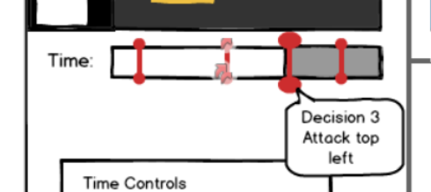

**#46 Once the blue diamond is selected and deselected, the maps still pull up from before (Design Constraint)**

**Before:**

This was a bug in the system. Even when the blue diamond was deselected, upon clicking the tabs the maps and graphs from the last decision point would show up.

**After:**

We got rid of those features. There are no more tabs. Now only selecting a decision point will open the graphs and the maps in the viewer, and hovering over it will open it in the preview.

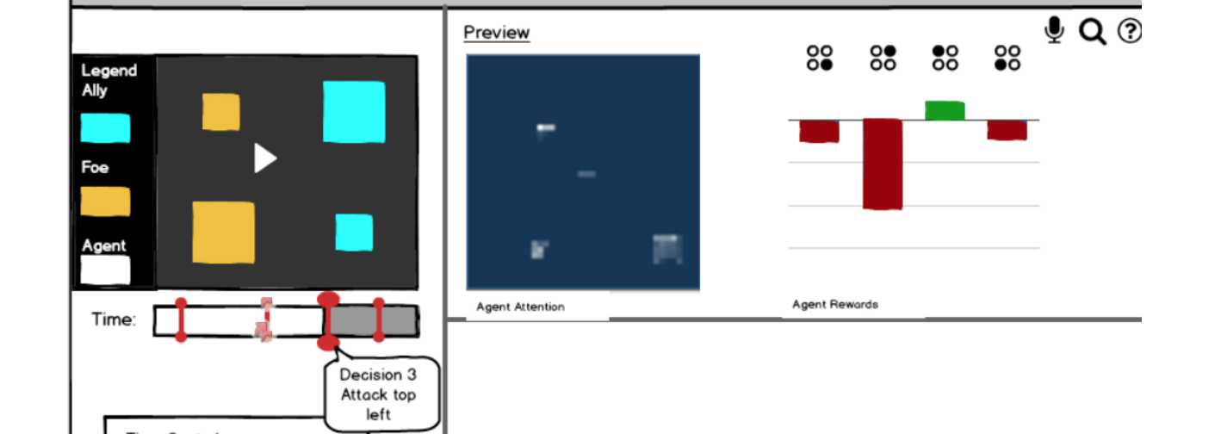

**#26 Unnecessary Step (Having to click the Blue Diamond to gain more information) (T&T #14)**

**#4 Having to click the blue diamond is Forced Syntax (T&T #7)**

**Before:**

The blue diamond was the only way to get information. However, it was hidden causing the user to never gain any information unless it was clicked.

**After:**

While the file plays, even if the user never realizes that they need to interact with the red lines, once the time reached to a decision point on the timeline, the preview window will show the attention map and the rewards graph pertaining to that time for a few seconds. This will further prompt the user to interact with the timeline.



**#5 The only dynamic time information is given by ‘steps’- bad for info processing style (HE Info Processing)**

**#9 The labeling of the timeline is a bit misleading**

**#14 Timeline proximity to step counter (Gestalt Proximity)**

**Before:**

There were two timelines, one called steps 1/n which was like a regular video player timeline. The other was called explanations which contained the blue diamond. The labels were confusing and far from the timelines.

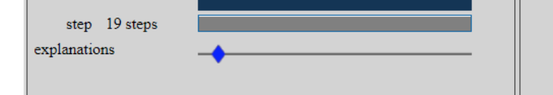

**After:**

We took out the blue diamond and the timeline it was on. Instead we combined the timeline with the decision points to make a single bar. We labeled it time to avoid any confusion. We took out any time left or time remaining, because there can be confusion as to whether time has the unit of seconds or steps.

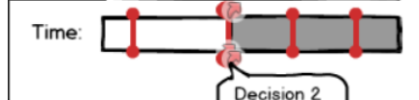

**#44 Pause button freezes (T&T #9)**

**Before:**

This was a bug in the system. When the user paused the video, instead of changing to a play button, the pause button froze. And the user had to click the pause button twice to resume the video.

**After:**

We are ideally assuming the bug will be fixed. Such that when the video plays, the pause button will show and when the video is paused the play button will show in the time controls box.

We also put all the time controls in a box to avoid any further confusion.

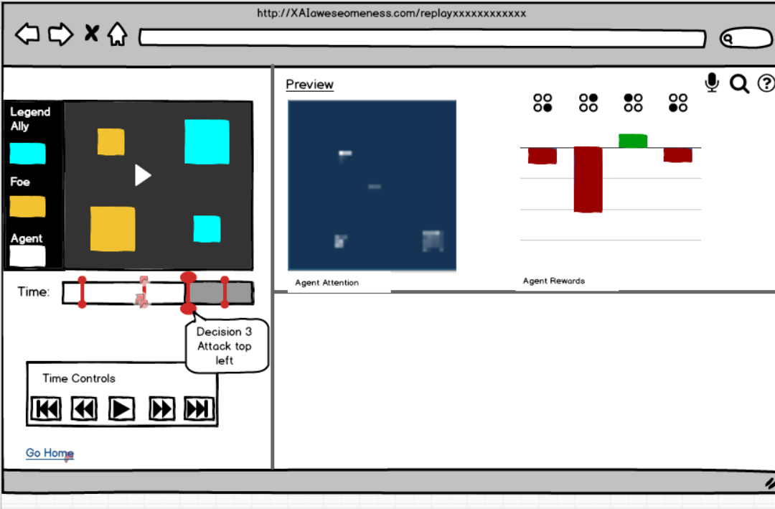

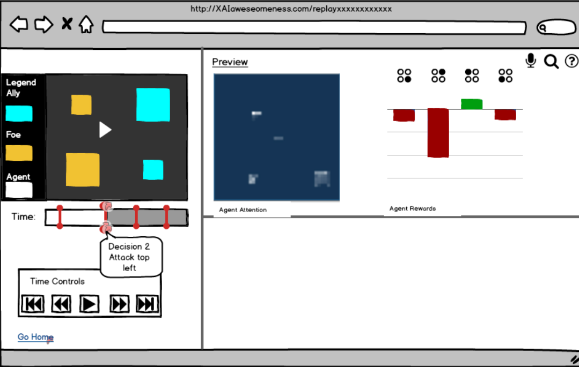

## The Preview: Fixed Feedback Failure

**Rationale:**

* Design Principles (Visibility)
* Design Principles (Feedback)
* Heuristic Evaluation (Learning)
* Tenets & Traps (effectively invisible elements)
* Heuristic Evaluation (Attitude Towards Risk)

**Bugs Fixed:**

**#1 Tabs have word ‘Saliency’ in it which user doesn’t understand (T&T #4)**

**#34 Feedback Failure (clicking tabs for rewards graph or saliency maps before activating BD doesn’t work) (T&T #9)**

**Before:**

The tabs to obtain the Saliency graphs read ‘Combined Saliency’ and ‘Specific Saliency’. These tabs were visible even when the blue diamond was not clicked. this caused frustration in the users, making them feel ‘stupid’ because they clicked and clicked and nothing happened. The word Saliency means nothing to the user.

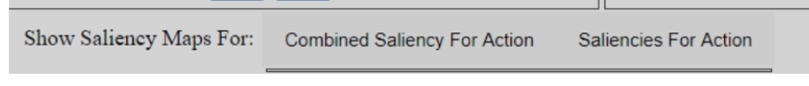

**After:**

We removed the empty saliency tabs. Instead of having to click on the decision points (now red lines with dotted ends), hovering over these decision points will show the preview of the map and the graph on the preview window as long as the cursor stays there. The word ‘Saliency’ has been replaced by ‘attention’ which makes much more sense to the user.



**#43 Minimal feedback from the blue diamond (noticeable/comprehendable) (T&T #9)**

**Before:**

There were 2 states associated with the Blue Diamonds. No information or all information. The user wouldn’t know what the blue diamond is for, what it meant, why that was located there etc etc.

If they managed to click it, there would be so much information that the user forgets all about the blue diamond.

**After:**

It was necessary to provide two kinds of feedback to the user. 1. What were decision points that showed up as red lines (blue diamonds previously). 2. What other information (if any) do these decision points contain.

We designed it so that, when a user hovers over the red lines, a tooltip expands and states the decision point number and the decision made at that point. Along with a preview of the combined attention (saliency) map and the graph.



**#28 Information overload (people are frustrated from long period of lack of information, but when the information shows up, oh boy does it show up….) (T&T #16)**

**Before:**

After a long period of no information, all of a sudden all information showed up. this frustrated and confused our users. Some of them even thought that they broke the system.

**After:**

The preview solved the issue by showing aggregated information when hovered over, so that the user can choose which decision point to select. Upon clicking, the same aggregated information would be snapped down to the viewer window. Hovering over the aggregated saliency map or graph will then show the exploded maps and graphs per channel.

This bit by bit information that the user achieves, not only improves the path through the task, but also does not overwhelm the user with too much information at once.

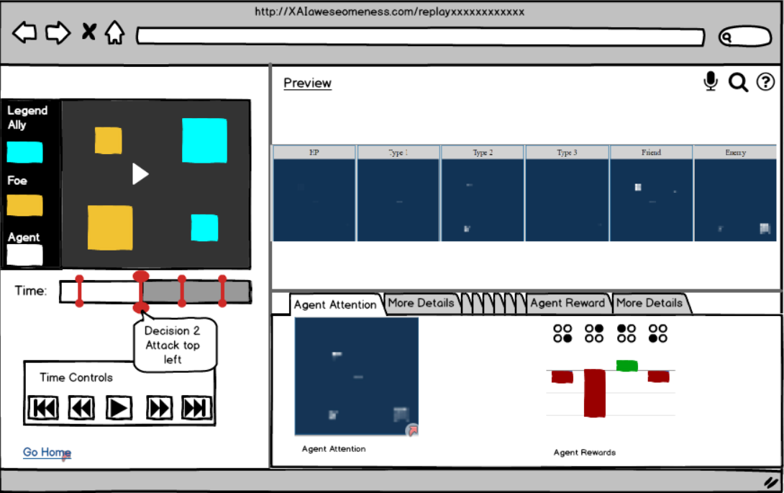

## The Viewer: Snapping Information

There was one more issue, the user could either see an aggregate information or an exploded information. There was no way to compare them.

* Heuristic Evaluation (Attitude towards risk)
* Heuristic Evaluation (Information Processing Style)
* Tenets & Traps (Memory Challenge)

**Bugs Fixed:**

**#51 Red not historically associated with friend (Design External Consistency)**

**Before:**

The two colors of towers on the map were red and blue. The red were the friendly towers and the blue were the enemy towers.



**After:**

We changed the colors to cyan and ochre yellow. We added a legend on the left side of the map to reduce memory challenge on the user.

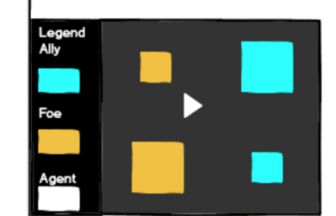

**#52 Hard to relate graph label to towers on the map**

**#48 Graph bar actions from left→ right reads attack bottom-right → top-left.**

**#47 Actions in a non-intuitive order**

**Before:**

The graph showed the rewards associated with the 4 different attack possibilities. However, the attack positions were mentioned in the bottom, and it was hard to relate which bar related to which towers.

Also, the bars read attack top left to attack top-right, which is non-intuitive.

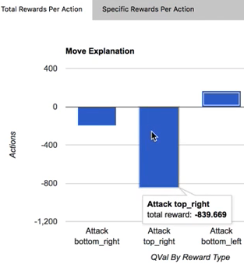

**After:**

We added four circles for each graph in a square form. The circle corresponding to the location of the tower would be filled out. The rest would be left blank. This gives a quick insight into which tower each bar belongs to and the user doesn’t have to go back and forth between the replay file and the graph anymore.

We also placed the bars for each tower in a counterclockwise manner. That is bottom-right followed by top-right followed by top-left etc. This is a natural way the user can slowly start to interpret the graph quicker.

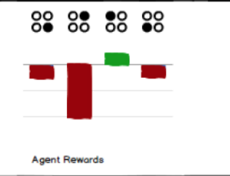

**#50 Blue squares on a blue background (Colour wheel)**

**Before:**

The replay file had a blue background and a the enemy tower was blue. It was hard to identify the small blue tower on the blue background on some displays.



**After:**

We changed the background of the replay file to dark grey. The enemy is now yellow and the the friend in cyan. This has enough visual contrast to identify the elements on the replay file.



**#49 Graph legend colours contradict enemy/friend colours (Design Consistency)**

**#38 Inconsistent Appearance (Graph colour is red for enemy_kil, tower red is friend. Inconsistent!) (Design consistency)**

**Before:**

The graph color was blue for the total rewards. And the enemy towers were also blue. There was scope of confusing that all the blue bars in the graph related to the enemies.

In the exploded view, the red bars were for enemy kill, whereas the red towers were friendly towers. This was a major contradiction in interpreting the graph.



**After:**

We changed the friend and enemy tower colors to more neutral ones and added a legend for easy reference.

We changed the total rewards graph to have red bars when the graphs pointed to negative score, and green bars when there was positive score.

In the exploded rewards graph, we didn’t change any color. However, since we changed the friend and enemy color on the replay file to begin with, there is no more confusion. In the future, we plan on changing the color of these bars to more intuitive ones.

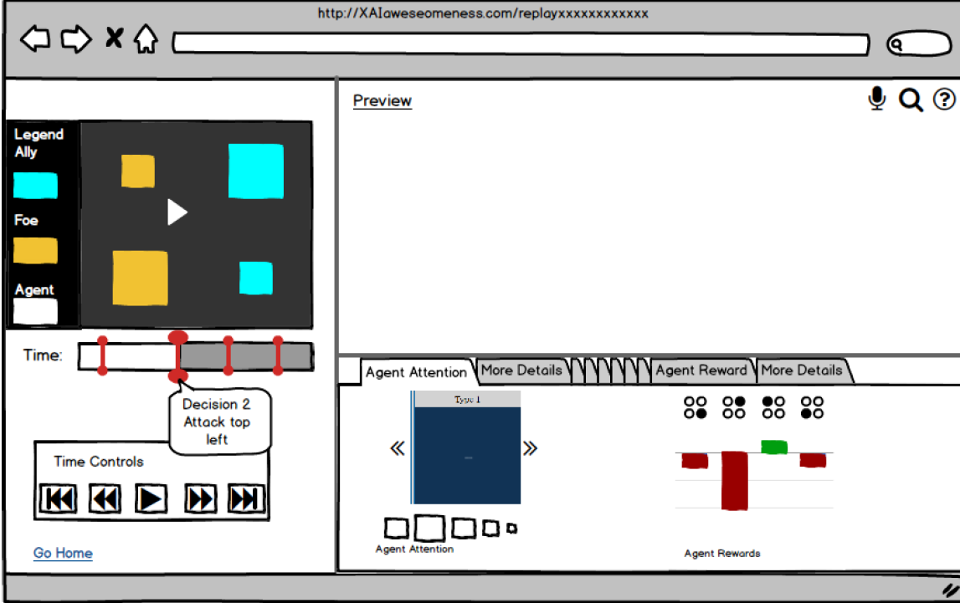

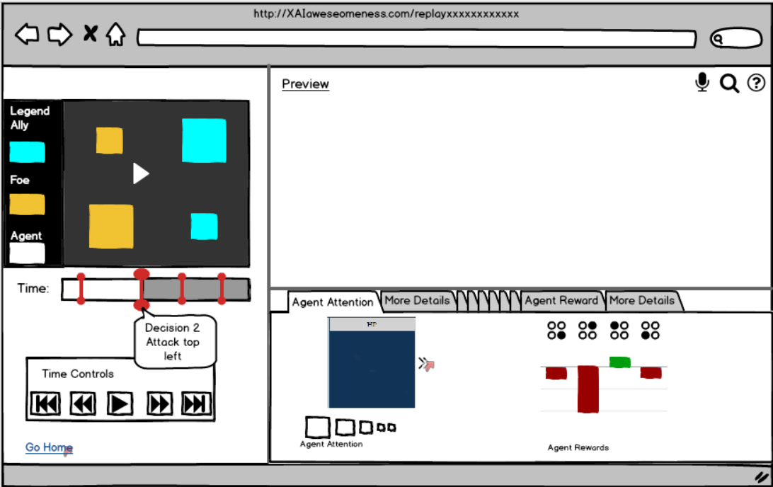

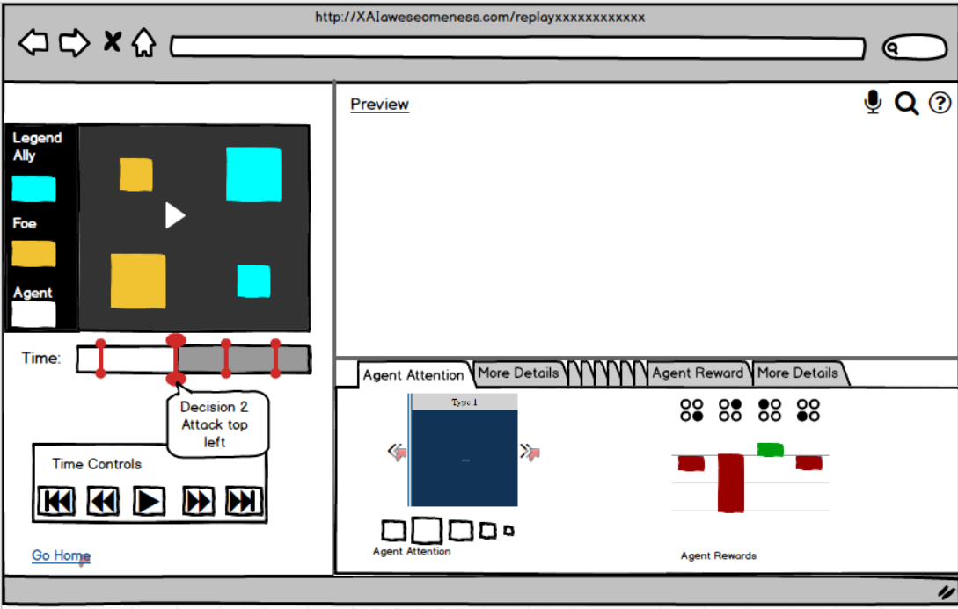

## Snapped Saliency Feedback (Drill down functionality)

* Design Principle (Feedback)
* Heuristic Evaluation (Information Processing Style)
* Tenets & Traps (Memory Challenge)

**Bugs Fixed:**

**#36 Unattractive Appearance (This UI has a generally unattractive appearance) (T&T #26)**

**#23 Inviting Dead End (Clicking rewards graph tab or saliency maps before activating blue diamond doesn’t work right) (T&T #5)**

**Before:**

The UI had very sparse information. However, it contained 4 tabs which had no information causing the user to be frustrated. The figure/ground problem was not well addressed. and when the information was loaded, there was an overabundance of it.

**After:**

Our redesign makes the UI more aesthetic, minimal and generally attractive. There are no unnecessary elements, giving the user a cleaner canvas to work with. Information appears Just-In-Time as the task progresses and the information appears one at a time, not causing the user to be overwhelmed.

**#18 More saliency below window (T&T #5)**

**#19 More saliency to the right of window (T&T #5)**

**Before:**

Previously, the 6 saliency maps were displayed in a row. If the user chose to see saliency maps for other attacks, they would show up below as a 2nd row of 6 more saliency maps.

However, our user resized his window in a way that smoothly cut off after 3 saliency maps. Our user didn’t know that there were additional maps until prompted.



**After:**

The preview window shows all the 6 maps when hovered over the aggregate map on the viewer.

When the aggregate map is clicked, a concise view would open. There would be arrows on each side of the saliency map. Below the saliency map would be 6 small boxes in a row. The box for the current map number would be bigger and the following ones were perpetually smaller. This clearly indicated that there were more saliency maps to look at.



# Chapter 6 - Jake wants to see a continuous saliency map to see how the agent makes decisions over time:

# 

## We found Home

* For the above screenshot see the corresponding screens in Chapter 5

## 

## 

## XUI, Meet the Team, Info Screen, Main Replay Screen:

* For the above three screenshots see the corresponding screens in Chapter 5

## 

## 

## 

## 

## Voice Assistant Popup, Search by Keyword Popup & FAQ Popup:

* Observations (Participant couldn’t figure out workflow and struggled to find if continuous saliency maps existed)
* Tenets and Traps (Memory Challenge)
* Heuristic Evaluation (Learning)
* Design Principles (Feedback)
* Design Principles (External Consistency)

**Bugs Fixed:**

**#7 No feedback to see if continuous saliency maps are actually possible (Heuristic Evaluation)**

**#10 No information for the user about how to advance through the system over time (Heuristic Evaluation, Observation)**

**Before:**

Users could not get any clue about how to get information or if it is possible to get certain information.

**After:**

Users can use searching function by voice or keywords. When searching some keywords which we do not provide any information about yet, users will be given ‘No Results’ with some recommendation for the next search. Users also can see the most frequently asked questions with the answers briefly.



**#26 Having to click the blue diamond to gain more information (Heuristic Evaluation, Observation)**

**#28 People are frustrated from long periods of a lack of information, but when it shows up, oh boy does it show up… (Heuristic Evaluation, Observation)**

**Before:**

When users want to get information, it is required to click the blue diamond first. If users click any tab without clicking the blue diamond first, nothing happens. When the blue diamond is clicked, all the information show up.

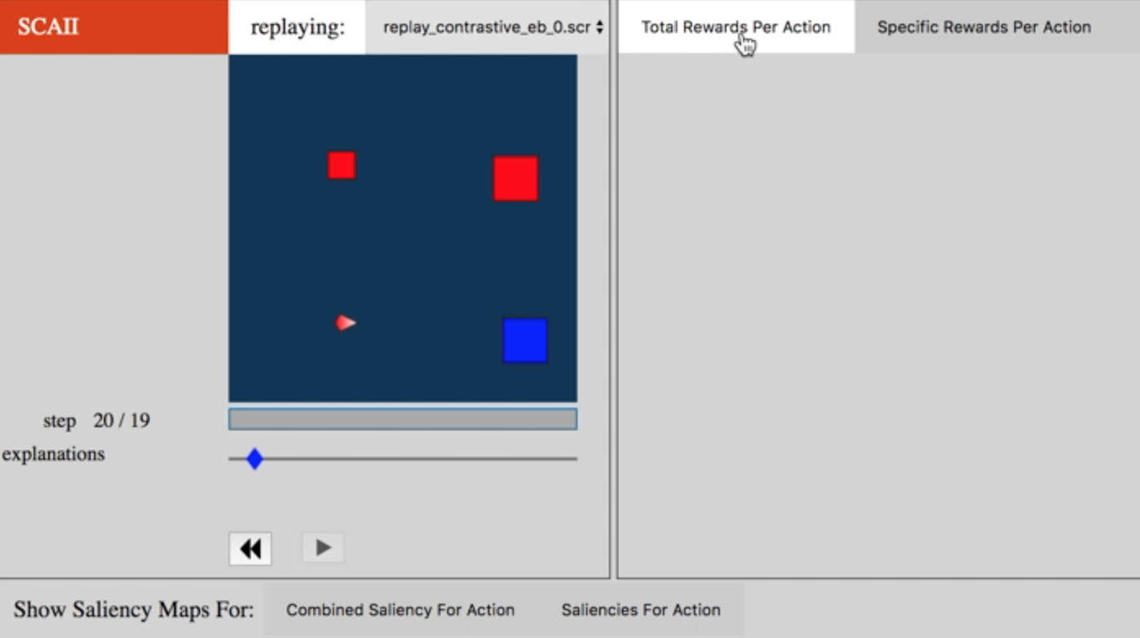

**After:**

Users can access only the information that they want to using searching function.

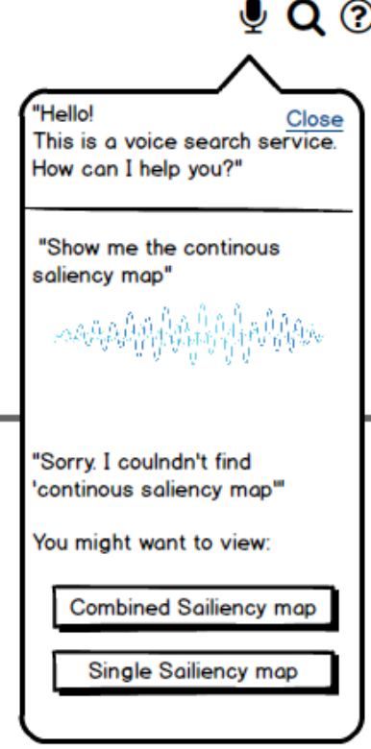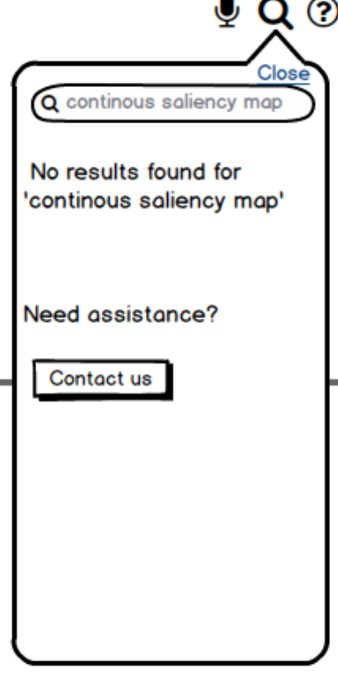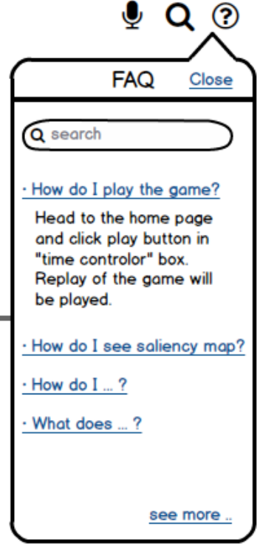

## FAQ Page:

* Observations (Participant couldn’t figure out workflow and struggled to find if continuous saliency maps existed)
* Tenets and Traps (Memory Challenge)
* Heuristic Evaluation (Learning)

**Bugs Fixed:**

**#7 No feedback to see if continuous saliency maps are actually possible (Heuristic Evaluation)**

**#10 No information for the user about how to advance through the system over time (Heuristic Evaluation, Observation)**

**#26 Having to click the blue diamond to gain more information (Heuristic Evaluation, Observation)**

**Before:**

Users could not get answers when they have questions or no way is given for that.

**After:**

Users can use search answers to their questions on the most asked questions list or searching those by topic.

# Chapter 7 - Jake wants to gain information about elements on the map by interacting with it.



## Legend of elements on the map

* Design principles (Visibility)
* Heuristic Evaluation (Information Processing Style)
* Tenets & Traps (Memory Challenge)
* Observation (Participant didn’t remember which was the friend and which was the foe)

**Bugs Fixed:**

**#8 Path through the task for process-oriented learners not there (Heuristic Evaluation: learning style)**

**#32 Remembering color for friend or foe (Memory Challenge)**

**Before:**

Users should know which color means friend or foe, but could not get any information about it.

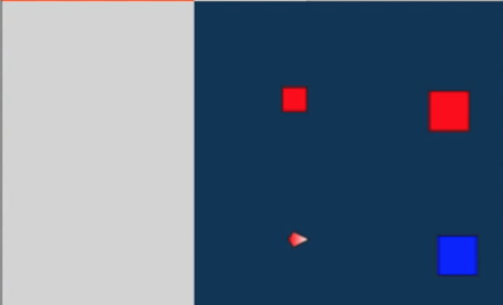

**After:**

Legend gives users information about which indicates Ally, Foe, or Agent.

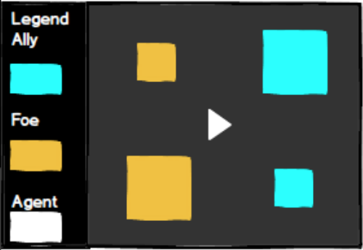

**#51 Red not historically associated with friend (Design External Consistency)**

**#50 Blue squares on a blue background (Visibility)**

**Before:**

Red color represents friends while blue color means foe. The blue tower is not very clear to see with the dark blue background.

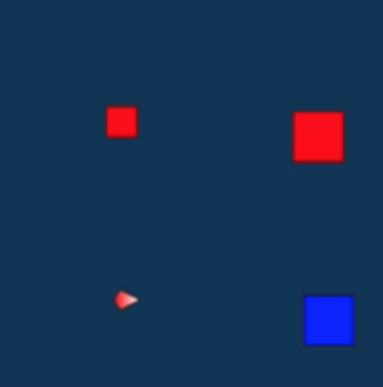

**After:**

Users can clearly see towers and agents by using bright colors for those on the dark colored background. Colors of towers and agent are changed in a way preventing bias.

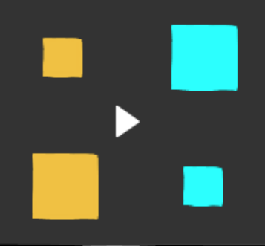

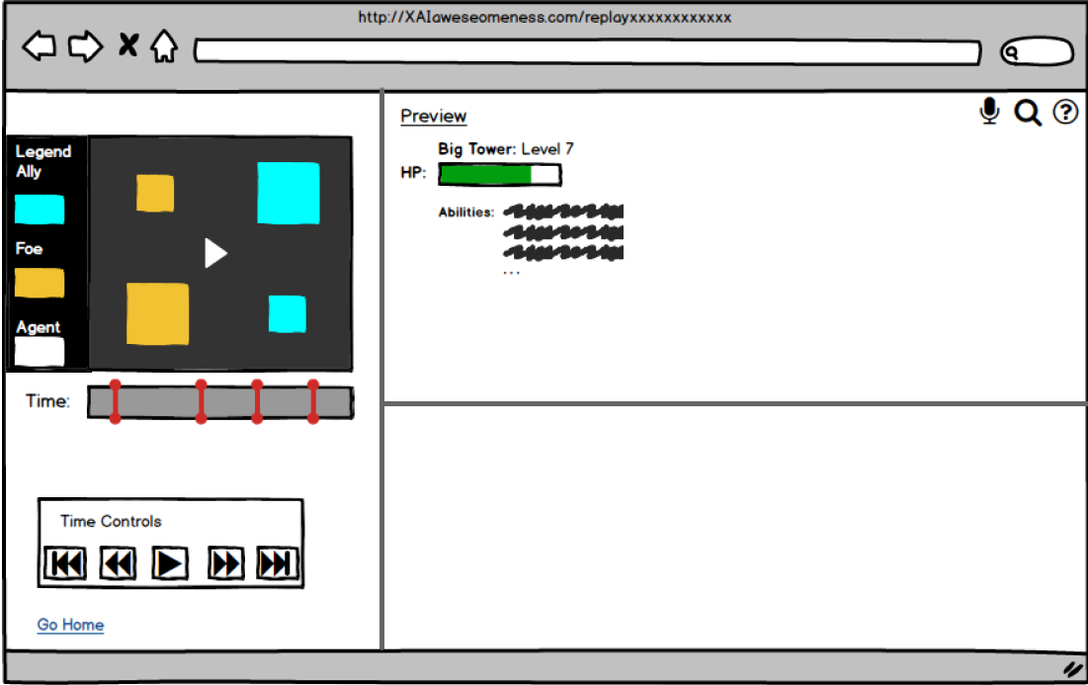

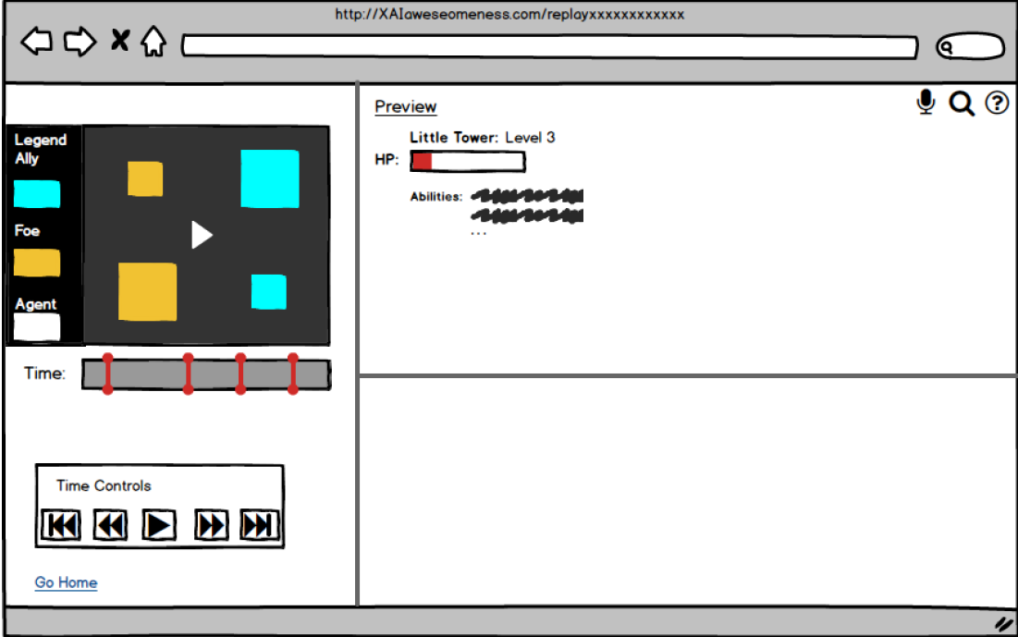

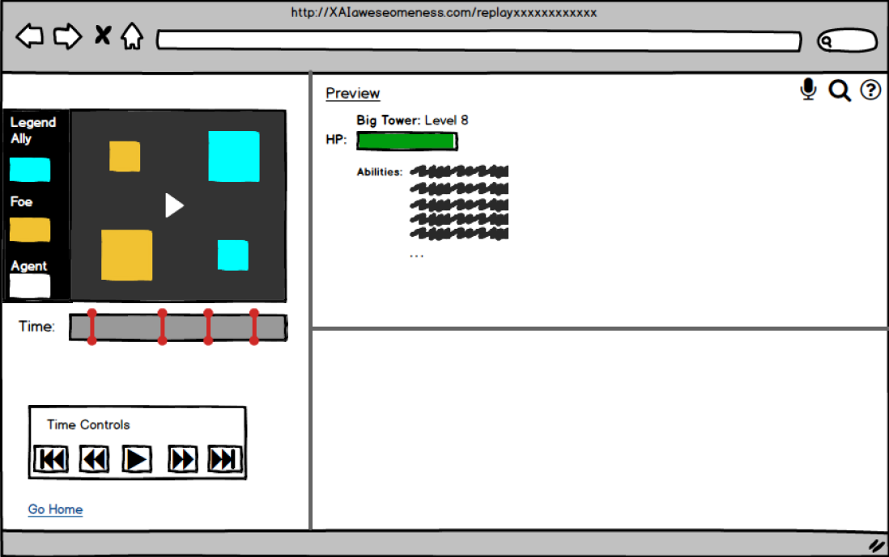

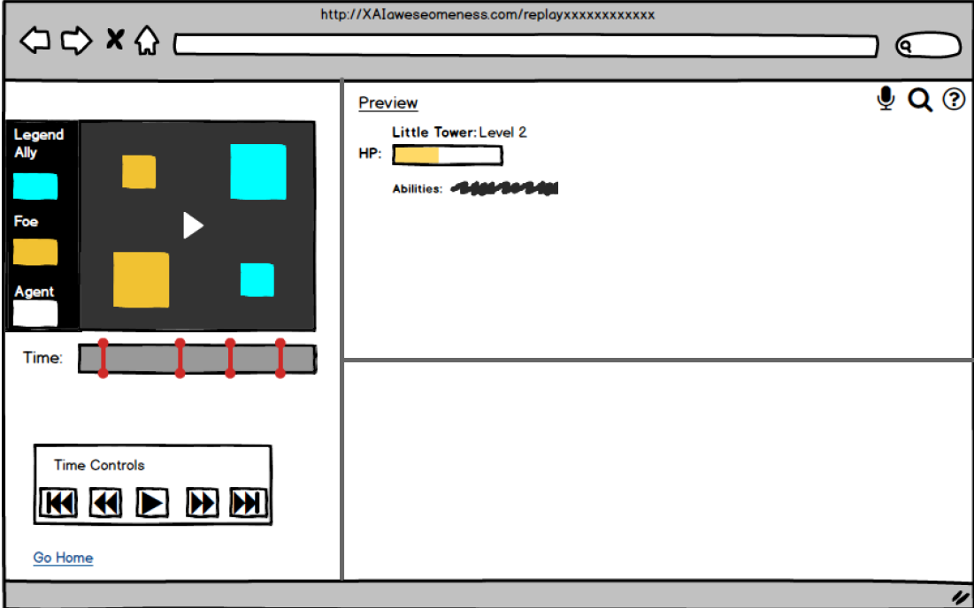

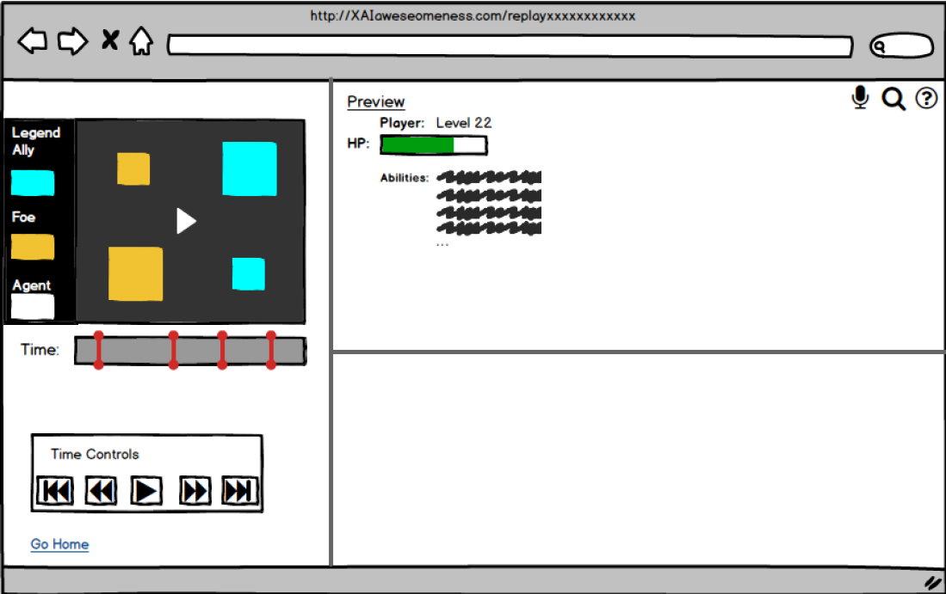

## More information about the elements on the map

Users couldn’t find more information about the elements on the map. The elements looked clickable, yet didn’t respond to clicks. This caused frustration in the users.

**Rationale:**

* Heuristic Evaluation (Information Processing Style)
* Tenets & Traps (Unattractive Appearance)
* Observation (Participant confused rewards to be related to HP. We fixed it by showing HP of towers and agent upon hovering.)

**Bugs Fixed:**

**#8 Path through the task for process-oriented learners not there (Heuristic Evaluation: learning style)**

**#36 The UI has a generally unattractive appearance (Heuristic Evaluation)**

**#54 Could not get enough information about the elements on the map (Observation)**

**Before:**

Users could not interact with the elements on the map. Only graph is given providing the information about rewards given when each element is attacked.

**After:**

Users can interact with the elements on the map, and get information about those such as HP, and abilities by clicking each element.

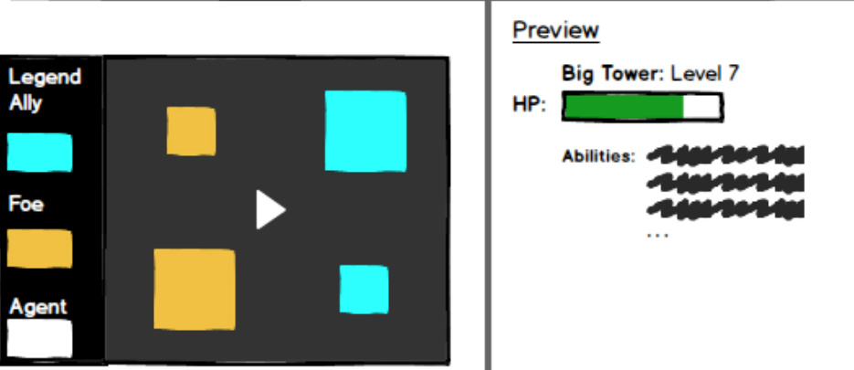

# Appendix A - Future Use Cases

1. Jake wishes to do an additive view and an exploded view of the saliency maps.
2. Jake wishes to overlay the saliency maps with the given map to gain further insight to the agent’s fixations.
3. Jake wishes to scroll back to any time in the timeline to learn more about decision points at a specific time point.
4. Jake wants to know which saliency map is the most useful at a decision point.
5. Jake wants to view different replay files.
6. Jake wants to compare two different decision points on a timeline and see the different saliency maps to compare.
7. Jake wants to look at when an object is the most important or when the agent looks at it the most.

# Appendix B - Pre-Session Questionnaire

1. Name

2. Age

3. Gender

🗆 FEMALE

🗆 MALE

🗆 OTHER

4. What is your major?

5. What is you all-time favorite RTS game?

6. Approximately, how many hours per week do you play RTS games?

7. What is your preferred platform when playing RTS games?

Task

This is a tower capture game. The blue are your enemies, the red are your friends. The tiny triangle in the centre is the player who plays the game.

This is a replay of the game played.

Find out why the player makes the decision in the game by retrieving more information from the application.

# 